# Chapter 3

# Root volume distribution of maturing perennial grasses revealed by correcting for minirhizotron surface effects

## 

## Abstract

Root architecture is a key driver of plant ecology and physiology, but our current understanding of root placement in the soil profile is limited and biased by current detection methods. To better characterize the root placement and carbon-storage potential of land-use changes from conventional agriculture to perennial grass biofuels, we developed a statistical model to allow robust depth- and time-resolved measurements of standing root volume from minirhizotron images. By correcting for small sample sizes and near-surface underdetection effects, our Bayesian model explained 30% of the variation in observed root length and validated well against root mass from paired core samples. In their seventh growing season, all three perennial grasses (*Miscanthus $×$* *giganteus*, *Panicum virgatum*, and a community of 28 tallgrass prairie species) had 11-16 times more belowground biomass in total, and 2-17 times more mass at every individual depth from 0 to 128 cm, than annually tilled maize and soybean. Perennial crops showed little change in the proportion of root volume allocated to each soil layer through time, but total root volume increased through the five years of the experiment and appeared resilient to a historically hot and dry summer in 2012, suggesting that large-deep root systems helped these crops resist drought. Because the root systems produced by these grasses are large, deep, and persistent, conversion from row crops to perennial biofuel grasses is likely to sequester carbon in a large and potentially very stable soil pool.

## Introduction

The placement of plant roots in the soil profile is an ecological trait that affects many ecosystem properties. Deeper roots provide structural support, give access to deep water and nutrient pools (Wasson et al. 2012, Zwicke et al. 2015), and store carbon (De Deyn et al. 2008). Meanwhile shallower roots are less costly, give access to larger but potentially less reliable water and nutrient pools (Lynch and Brown 2001, Hodge 2004, Nippert et al. 2012), and promote competitive success through root-zone exclusion (Genney et al. 2002). The existence of mycorrhizal associations lead to further tradeoffs between root architectures optimized for soil exploration by the root itself or by the mycorrhizal symbiont (Comas and Eissenstat 2009, Liu et al. 2015). Understanding root distributions is therefore fundamental to predicting ecosystem functioning (Bardgett et al. 2014) and improving management outcomes (Kochian 2016).

For the present study, we quantified root distribution in the context of evaluating the ecosystem-level effects on soil C cycling of a change in land use from annual row-crop agriculture to perennial grasses managed for biofuel production. Some researchers have suggested that biofuel grasses may build soil C because of their large root systems and minimal tillage requirements (Anderson-Teixeira et al. 2013, McCalmont et al. 2015, Agostini et al. 2015), and some have further proposed that any C gains from biofuel grasses may be especially persistent because of preferential allocation to deep soil and consequent slower turnover (Balesdent and Balabane 1996, Rasse et al. 2005, Kell 2011, Rumpel and Kögel-Knabner 2011, Agostini et al. 2015, Prieto et al. 2016, Ward et al. 2016). However, to evaluate this claim we need a better idea how much C is added, where it is distributed in the soil, and its turnover time (Agostini et al. 2015).

Understanding of root distributions is much less detailed than our understanding of aboveground traits. This lack of detail is exacerbated by notable drawbacks in the available methods of quantifying root systems (Pierret et al. 2005, Milchunas 2009, Topp et al. 2016). Pot effects mean container studies are only realistic for very small plants (Poorter et al. 2012). Destructive approaches such as coring and trenching give accurate snapshots, but require massive effort (hours to days per sample; Bohm et al. 1977) and cannot be repeated through time. Furthermore, because the effort required for coring and trenching increases rapidly with depth, many such surveys have focused only on the shallow soil layers (typically 30 cm or less), often leading to severe underestimates of deep root mass (Mokany et al. 2006). Imaging systems such as minirhizotrons give time-resolved data, but with the tradeoff that the data are noisier and indirect; the raw data are two-dimensional images that must be converted to a three-dimensional volume estimate and then converted again from a volume to a mass, with further possible noise and biases in the conversion (Metcalfe et al. 2007, Taylor et al. 2014).

Minirhizotron observations of standing root mass seem to be especially susceptible to depth biases; previous workers have often reported that minirhizotrons underdetected roots in the shallowest soil layers, probably because of movement of either the tube or the soil leading to poor contact between tube and soil in the least compacted and most frequently disturbed surface horizons (Bragg et al. 1983, Taylor et al. 1990, Parker et al. 1991, Samson and Sinclair 1994, Ephrath et al. 1999). Most previous workers who considered this bias have discarded data from the affected layers (potentially containing the majority of the root system; Samson and Sinclair 1994), used paired comparisons within layers, or equivalently developed depth-specific calibration factors. None of these approaches were satisfactory for us because we wanted to compare both total root volume and the fraction of roots found in a given layer over time and among species.

In this study, we tracked the change in root volume associated with a change in management from annually tilled conventional row crops (maize and soybean) to untilled perennial grasses mowed annually for biofuel feedstock. We used minirhizotrons to track seasonal and interannual patterns in root distribution to a depth of >1 m, developed a statistical model to account for biases from underdetection and small samples, and verified our estimates with deep-soil core samples. We predicted that root volume under perennial grasses would be much higher than under row crops, that the root growth season would be longer, and that root systems would reach their maximum extents in the same year each crop achieved maturity as measured by aboveground yields.

## 

## Methods

### Site

Measurements were made at the University of Illinois Energy Farm, ~5 km south of Urbana, Illinois (40.06N, 88.19W, elevation 220 m). Climate, soils, and site establishment have been described in detail elsewhere (Zeri et al. 2011, Smith et al. 2013, Masters et al. 2016). Briefly, the site has a highly seasonal continental climate with a mean annual temperature of 11 °C (below 0 °C December-February, over 20 °C June-August) and average annual precipitation of approximately 1 m, with approximately half falling as rain during the growing season (May-September). Soils are deep and loess-derived, mapped as Argiudolls of the Dana, Flanagan, and Blackberry series of silt loams. Four cropping treatments, each representative of a possible bioenergy cropping scheme, were established in 2008. The treatments were a three-year maize-maize-soybean rotation that was tilled annually and managed in accordance with typical Central Illinois cropping practices, a prairie restoration mix of 28 native species (Zeri et al. 2011), and two perennial grasses: *Miscanthus × giganteus* Greef and Deuter ex Hodkinson and Renvoize (*Miscanthus*; cv “Illinois”) and *Panicum virgatum* L. (Switchgrass; cv “Cave-in-Rock”). The site was planted in a randomized complete block design replicated five times, with four blocks of 0.7 Ha plots and one block of 3.8 Ha plots (Masters et al. 2016). Each large plot was instrumented to record weather, crop growth parameters, and ecosystem C and water exchange.

Maize and soybeans were planted and harvested according to local practice. Switchgrass and prairie were planted in 2008 and not subsequently replanted; *Miscanthus* survived poorly the first winter and therefore the large *Miscanthus* plot was replanted in 2009. Standing biomass from perennials was mowed and baled after senescence each winter.

Maize was fertilized each year with 202 kg N Ha-1 yr-1 before planting; no fertilizer was applied to soybean. Switchgrass was fertilized with 56 kg N Ha-1 yr-1 applied before crop emergence. Initially, neither prairie nor *Miscanthus* were fertilized. In 2014 the small *Miscanthus* plots were split and one half of each 0.7 Ha plot remained unfertilized while the other half, and the entire 3.8 Ha plot, recieved 56 N Ha-1. For all 2014 *Miscanthus* values, we report means averaged across fertilizer treatments.

### Rhizotron tube installation and maintenence

To observe root systems over time, in May of 2009 we installed 96 clear acrylic minirhizotron tubes. We placed 24 tubes in each crop, with 4 tubes (one in each quadrant) per 0.7 Ha plot and 8 tubes (2 in each quadrant) per 3.8 Ha plot. Each tube was 1.8 m L $×$ 51 mm ID $×$ 57 mm OD (Bartz Technology corporation, Carpinteria CA USA) and was installed using a tractor-mounted hydraulic probe (Giddings Machine Co., Windsor, CO USA) at an angle 30° from vertical (Bragg et al. 1983). For perennial crops, we placed tubes randomly within each quadrant. For maize and soybean, we placed half the tubes in each plot directly within rows and the other half midway between rows. Each tube’s vertical angle was aligned along a row, so comparisons of root density between depths in a single tube were not confounded with row placement. Each tube was inserted until 22 cm remained aboveground or until it was stopped by soil resistance, allowing image collection from the soil surface to a depth between 115 and 140 cm. The aboveground portion of each tube was capped to minimize intrusion of light, water, or temperature swings.

Tubes in maize and soybean plots were installed immediately after planting every spring and removed after harvest to allow tillage. The tubes in perennial crops remained permanently installed, but each winter a portion of the permanent tubes developed leaks in their bottom end caps, and were replaced the following spring in a freshly bored hole at least 1 m away from the previous location. Of the original 72 tubes ‘permanently’ installed at the site, 39 survived to the end of the experiment in their initial location. Because of ongoing tube failures after repeated installation and a limited stock of replacement tubes, in 2014 we were only able to collect images from 8 tubes in maize, all in the 3.8 Ha block.

### Image collection

From 2010 through 2013, we collected images approximately once a month during the growing season (May to October) using a portable minirhizotron camera (BTC-100x; Bartz Technology). In each session, we first used a long-handled swab to clean dust and condensation off the inner surface of the tube. We then mounted the camera into the tube and collected images at ~6-cm vertical increments until the camera reached the bottom of the tube (typically ~125 cm). Each tube’s offset from the soil surface was remeasured periodically and used to correct image depth estimates. The 6-cm vertical increment came from collecting images every five stops of the depth-indexing handle (13.5 mm per stop $→(5⋅1.35)cos(30°)=5.8$ cm) and was chosen as the spacing that best balanced adequate sampling from each tube against the time required to process each image after collection (Johnson et al. 2001).

The resulting images were 754x510 pixels and the camera was calibrated daily by photographing a 1x1 mm grid attached to the outside of a short length of rhizotron tube (same viewing distance as the roots). The final maximum image resolution was ~0.025 mm per pixel.

### Image processing

In the laboratory, we recorded the length and diameter of every visible root segment by manual tracing using WinRhizo TRON MF v. 2009a (Regent Instruments, Québec QC, Canada) and performed all downstream analyses on the total volume of root visible in each image assuming each root segment was a perfect conic section with dimensions (Diameterstart Diameterend length). Rhizotron methods have low success distinguishing living from dead root tissue (Iversen et al. 2011), so we made no attempt to classify tissue death status. Thus all our root density estimates include visible root necromass.

To minimize human variation in tracing, all technicians were trained using the same set of representative images and the agreement in traced root volume from each image was taken as an estimate of the variation among workers given the same task. The variation among workers was less than the within-worker variation (95% intervals: sd among workers = 1.2-1.6 mm3 img-1, sd within worker = 2.4-2.7 mm3 img-1; data not shown), indicating that technician identity was a minor contributor to the variation in the tracing step. Since these agreement scores were taken from novice tracers immediately after the completion of their training, it is likely that they somewhat overstate the actual variation from experienced technicians.

After tracing, each season’s data were aggregated using a set of custom R scripts to adjust observed root volumes for differences in image magnification, remove data from images with poor image quality, convert locations within each tube to depths below the soil surface, and aggregate results across experimental blocks. The full data and all scripts are available online (https://github.com/infotroph/efrhizo).

### Root mass measurements

To compare estimates of root density from minirhizotrons and destructive coring methods, we collected deep-soil cores. In August of 2011 and of 2014, when aboveground biomass of all four crops was near its yearly maximum, we collected soil cores to a depth ≥ 100 cm from 24 locations within each crop (4 from each 0.7 Ha plot, 8 from each 3.8 Ha plot) using a tractor-mounted hydraulic corer (Giddings Machine Co.). Because the heavy coring equipment necessitated trampling a large (~2-3 m) quadrat at every location, coring locations were all within 3 m of a plot edge. At each location, three 3.8 cm diameter cores were collected from within a 1-m area. We divided each core into five depth horizons (0-10, 10-30, 30-50, 50-100, and 100+ cm), pooled horizons from the same location, then separated root and rhizome material from soil by hydropneumatic elutriation (Roberts et al. 1993), separated rhizomes from roots by hand-sorting, oven-dried both to constant mass, and weighed them.

Since individual locations within a plot are pseudoreplicates, we calculated block means of root mass per cm3 soil (for depth-resolved analyses) or per m2 ground area (for whole-profile totals), log-transformed the result, then fitted a mixed-effects linear model where ln(depth) is a continuous covariate, crop and year are categorical fixed effects (Equation 3.1), block is a categorical random effect (Equation 3.2), and residuals follow a first-order autoregressive function within each level of the (block by crop by year) interaction to account for the autocorrelation between adjacent depths (Equation 3.3).

$$ln(y_{ijkl})=β_{i}{crop}_{i}+β_{j}{year}_{j}+β_{k}ln({depth}_{k})+γ_{l}{block}_{l}+ϵ_{ijkl} (3.1)$$

$$γ_{l}∼N(0,ψ_{ijk}^{2}) (3.2)$$

$$ϵ_{ijkl}∼N(0,σ^{2}λ_{ijkl}), corr(ϵ_{ijkl},ϵ_{ijkl^{'}})∼ϕ^{|l^{'}-l|} (3.3)$$

All root core statistics were performed in R version 3.3.0 (R Core Team 2016) using nlme 3.1 (Pinheiro et al. 2016) for linear model fits followed by lsmeans 2.23 (Lenth 2016) for predicted marginal means and post-hoc treatment comparisons. The data from 2011 have been presented previously (Anderson-Teixeira et al. 2013); we limit our discussion here to the comparison against simultaneously collected rhizotron images from the same plots.

### Bayesian modeling of root volume

To convert root areas estimated with error from minirhizotron images into an estimate of root volume distribution across depth, we used a Bayesian model to integrate image data with prior knowledge about plant architecture and growth patterns to produce a mathematically tractable and physiologically defensible estimate of root density in each crop. The basic structure of the model was formulated by Sonderegger et al. (2013) for root production estimates; we adopt it here with modifications to estimate standing root volume.

We began with a log-linear mixed model of root volume (mm3 root observed per mm2 of image traced) similar to the one used for root mass from cores (Equation 3.1). On a given sampling day, the expected log root density $μ_{ijk}$ (Equation 3.4) declines with log depth according to a crop-specific intercept $α_{i}$ and slope $β_{i}$, and the intercept varies for each sampling location (i.e. minirhizotron tube) as a zero-centered random effect $γ_{j}∼N(0, σ^{tube})$:

$$μ_{ijk}=α_{i}+γ_{j}+β_{i}ln({depth}_{k})+ϵ_{i}. (3.4)$$

We treated individual minirhizotron tubes as the unit of replication (rather than block means as in the core data) because the observed variation among individual minirhizotron tubes was much larger than the variation among blocks and therefore subsumes the block effects; it should be possible to calculate the block effect, if it is needed, as the mean of the estimated tube effect coefficents of all tubes in that block.

Next, we added an empirical correction for reduced minirhizotron root detection efficiency near the soil surface. The cause of this underdetection is still unclear, but it is commonly observed in minirhizotron studies (Bragg et al. 1983, Taylor et al. 1990, Samson and Sinclair 1994, Ephrath et al. 1999, Gray et al. 2016). We corrected for this underdetection by noting that when measured directly it appears to be sigmoid with depth, and when not measured it can be inferred by a visible deviation from the log-linear depth trend in near-surface layers, meaning the correction can be found by solving for a sigmoid underdetection function that brings near-surface observations back toward the linear depth model of Equation 3.4. Then the expected density of *detected* roots $\overset{^}{μ}$ (Equation 3.5) is:

$${\overset{^}{μ}}_{ijk}=μ_{ijk}logistic(α_{i}^{surface}+β_{i}^{surface}{depth}_{k}), (3.5)$$

where $α_{i}^{surface}$ is the depth at which 50% of roots are detected, $β_{i}^{surface}$ scales the rate of detection increase with depth, and both are estimated from observations but strongly informed by prior research (Supplement 3.S1).

Finally, we noted that individual images are small (~240 mm2) compared to the scale of root system heterogeneity, and many images contain no visible roots even when root density is high. The observed root volume in an individual image (Equation 3.6) therefore follows a mixture distribution (Sonderegger et al. 2013):

$$y_{ijk}∼\left\{\begin{matrix}0, with probability 1-ϕ_{ijk} \\ logN({\overset{^}{μ}}_{ijk},σ^{2}), with probability ϕ_{ijk}\end{matrix}\right., (3.6)$$

where the probability $ϕ_{ijk}$ of observing any roots (Equation 3.7) increases with expected root density ${\overset{^}{μ}}_{ijk}$ (Equation 3.5) as

$$logit(ϕ_{ijk})=α^{detect}+β^{detect}{\overset{^}{μ}}_{ijk}. (3.7)$$

We fitted this model separately to each day of data using the Rstan (Stan Development Team 2016a) interface to the Stan probabilistic programming language (Stan Development Team 2016b), which computes the joint likelihood of all model parameters given the observed data and uses Hamiltonian Monte Carlo sampling to draw from their posterior distributions. For each model, we ran five independent chains for 5000 iterations each, then discarded the first 1000 iterations as warmup, giving a total of 20000 Monte Carlo samples for each parameter and an effective posterior sample size (after accounting for autocorrelation) of at least 1000. We checked for convergence both visually by plotting the chains and by checking that the potential scale reduction factor was close to 1.0 (Gelman and Rubin 1992). All scripts needed to reproduce the analysis are available online (https://github.com/infotroph/efrhizo).

## 

## Results

### Soil core samples

Perennials produced far more root biomass than maize, and the difference became larger as the perennials matured (Figure 3.1). The belowground biomass of the perennial grasses in core samples increased dramatically from 2011 to 2014 (F1,28 > 66; p << 0.01), from 5-8 times greater than maize in 2011 whether measured as roots or as total biomass (Anderson-Teixeira et al. 2013) to 8-11 (root alone) or 11-16 (root+rhizome) times greater than maize in 2014 (Figure 3.1; all Tukey t28 > 7; all p << 0.01). When we considered roots alone there was an interaction between year and crop, with increases for *Miscanthus* and prairie (both more than tripled from 2011 to 2014; t28 > 5.5, p << 0.01) but not for maize or switchgrass (root mass was greater by 62% and 76% respectively, but the difference was not significant after correcting for multiple comparisons; t28 < 2.8; p > 0.15). When we considered total root+rhizome biomass, the year-over-year changes were similar in magnitude to those for roots alone, but the variability was greater and the year by crop interaction was not significant (F3,28=2.2; p > 0.1).

There were no statistically resolvable differences in belowground biomass among perennials in either year (all Tukey t28 < 1.6; p > 0.4), but the rank order of total mass depended on the year and the pool measured because of increases in rhizome mass. In 2011 switchgrass had the greatest mass (860±126 g root m-2, no rhizomes detected) and *Miscanthus* was second for total biomass (819±130 g root+rhizome m-2) but third for roots alone (535±79 g root m-2), while in 2014 prairie had the greatest root mass (1924±282 g root m-2) but *Miscanthus* had the greatest total mass (2793±444 g root m-2). For comparison, maize root mass was 109±17 (2011) and 177±26 (2014) g root m-2 (Figure 3.1).

Biomass in core samples declined approximately log-linearly with depth (Figure 3.2), but the distribution of biomass through the soil profile varied by species (F3,180 = 8.69, p << 0.01). Prairie roots were more concentrated near the surface and declined more quickly with depth than *Miscanthus* or maize (t180 > 3.5; p < 0.01). The decline in switchgrass was intermediate between prairie and maize and not significantly different from either one (all t180 < 2.6; p > 0.05), although the comparison with prairie was marginal in 2014 (t180 = 2.59; p = 0.0501), and switchgrass declined more quickly than *Miscanthus* in 2011 (t180 = 3.50; p < 0.01) but not in 2014 (t180 = 1.02, p = 0.69). When we modeled total root+rhizome biomass instead of roots alone, the slope by year interaction became significant (F1,180 = 4.99, p < 0.05), with the mass of all crops declining more with depth in 2014 than in 2011. With rhizome mass included there were no statistically resolvable differences in slope among perennials in either year, but *Miscanthus* and switchgrass changed from similar to maize in 2011 (t180 < 1.9; p > 0.2) to greater declines in 2014 (t180 > 2.9, p < 0.02) because of dramatic increases in rhizome biomass near the surface.

Despite the observation that root biomass for maize was more evenly distributed through the soil profile (less negative slope terms) than the perennial crops, the root mass of perennials at any given depth was greater than that of maize even at the bottom of the soil profile (Figure 3.1). Perennials had 2-17 times more root biomass than maize (post-hoc contrasts on fitted LS means; t180 > 3; p << 0.01) all the way to 128 cm, the mean maximum depth of our core samples, with the exception that in 2011 the difference between prairie and maize was marginal at depths greater than 1 m (t180 < 2.6; 0.05 < p < 0.1).

### Minirhizotron images: model evaluation

The Bayesian model of root distribution compensated well for poor surface root detection by the minirhizotron, explained ~30% of the total variance in log root volume, and showed little bias: 90% prediction intervals for individual images included the observed value 90% of the time, and 50% intervals about 50% of the time, indicating that both the mean and variance components were consistent with the data (Figure 3.S1).

Much of the remaining ~70% of variation is attributable to the inherent variability among source images and could be reduced by aggregating multiple images before testing model fit, but this is prevented by the model structure. After incorporating detection and surface effects, model predictions are in units of expected *corrected* root volume and their means can no longer be compared directly against the observed means of raw images, meaning the direct comparison of observed vs. predicted values is only valid at the level of individual images. Although the model structure prevents a quantitative comparison, qualitatively the shape of the depth function and the ranking of species differences agreed well with the patterns seen in soil cores (Figure 3.3), and did not show the reduction in near-surface root volume observed in the raw images. The model treated the variance from individual minirhizotron tubes $σ^{tube}$ and the detection probability parameters $a^{detect}$ and $b^{detect}$ as identical across crops, while the intercept, slope, surface underdetection parameters $α^{surface}$ and $β^{surface}$, and residual variance $σ$, were fit separately for each crop. Half-detection depths ($α^{surface}$; the estimated depth where the surface underdetection effect reduces to observations 50% of true root volume) ranged from 1 to 36 cm in maize, 14-35 in *Miscanthus*, 9-24 in switchgrass, and 11-26 in prairie, and tended to be greatest in midseason. We also attempted to fit an alternate model with $α^{surface}$ and $β^{surface}$ identical across all crops, but encountered numerical difficulties and lack of sampler convergence that suggested a very poor model fit (data not shown).

Although the model predicts root *volume* per area of image rather than root mass directly, predicted root volume for midsummer 2011 and 2014 scaled positively and log-linearly against simultaneously collected root masses from coring (Figure 3.S3) and overlapped with the values expected from a simple conversion based on previous research. If root volume per image area = (root mass)(depth of view)/(root tissue density), the dashed lines in Figure 3.S3 show the root volume expected from core mass assuming 0.78 mm depth of view (Taylor et al. 2014) and root tissue densities of 0.08 g cm-3 for maize (Pahlavanian and Silk 1988), 0.20 for *Miscanthus* (Wahl and Ryser 2000, Roumet et al. 2006, Picon-Cochard et al. 2012), 0.19 for switchgrass (Craine et al. 2001) and 0.15 for prairie (Craine et al. 2001). With the exceptions of maize (0%) and *Miscanthus* (45%) in 2011, model predictions accounted for at least 75% of the variation in block means of root mass from cores (Figure 3.S3).

### Minirhizotron images: changes in root distribution through time

Across the five years of the experiment, all three perennials increased their root volume (95% intervals for 2010 and 2014 model intercepts did not overlap; Figure 3.S2), while maize and soybean did not (95% intervals overlapped; Figure 3.S2), even though both annuals and perennials had the numerically lowest midsummer root volume in 2010 and the highest in 2014 (Figure 3.3).

The distribution of root volume with depth showed little change over time. Prairie roots were more concentrated near the surface in 2014 than in either 2011 or 2012 (slope term was more negative; 95% intervals do not overlap; Figure 3.S2) but no other crop showing detectable changes from year to year. Intriguingly, though, maize, *Miscanthus*, and prairie all showed their most even distribution and widest uncertainty intervals in 2012, a very hot drought year. This change can be seen in the predicted depth profiles as a reduction in near-surface root volume in maize, *Miscanthus*, and prairie, but no apparent change was seen in switchgrass (Figure 3.3).

When we followed root volume from month to month within individual growing seasons, the perennials showed strong seasonal changes in 2010 but did not change from month to month in 2012. In 2010 root volume under all four crops was higher in August than either May or October (95% intervals for intercept term do not overlap; Figure 3.S2). In soybean the distribution of roots in the soil also changed, with root volume strongly decreasing with depth in June and July but essentially vertical from midsummer through senescence (Figure 3.4; slope interval overlapped zero in August and October; Figure 3.S2). In contrast, root volume in the perennial crops rose from June through August and dropped again in October, but the depth distribution did not change substantially except in *Miscanthus*, where roots were more concentrated near the surface in July than in August (Figure 3.4; Figure 3.S2). In 2012, maize root volume increased from May through August (Figure 3.S2), but shifted its distribution dramatically from roots concentrated very near the surface in the first three observations to evenly distributed across depths in August (Figure 3.5). The 2012 maize crop senesced in August because of drought and was harvested in September, so no images were collected from maize in October. All three perennials, by contrast, were consistent in both total root volume and in depth distribution throughout the season. All three appeared to slightly reduce near-surface root volume late in the season (Figure 3.5), but these changes were not statistically resolvable except in prairie, where roots were concentrated nearer the surface in May than in either early August or October (Figure 3.S2).

## 

## Discussion

In repeated observations of four crop systems, we observed much more root both by mass and by volume in perennial grasses than in annual maize-soybean. The root systems of the perennials continued expanding across five years of observations, appeared resilient to a major drought, and allocated large quantities of carbon to the deep subsoil. By explicitly correcting for depth-dependent detection biases, we found good agreement between minirhizotron and core-based measurements of root mass, which may allow nondestructive monitoring of root structure and C stocks in familiar units. The combination of greatly increased root mass and allocation deep in the soil suggest that conversion from row cropping to perennial grass biofuels could result in large-scale soil C increases.

Our measured root masses agree well with previous work that shows much larger root systems in perennial grasses than in annual crops, and that root mass stays high even during the spring and fall when annual fields are fallow. We observed switchgrass root masses comparable to those from other stands of similar age that were sampled to a depth of ≥90 m (Frank et al. 2004, Monti and Zatta 2009, Collins et al. 2010, Garten et al. 2010, Dohleman et al. 2012) and higher than those sampled to shallower depths (Bransby et al. 1998). *Miscanthus* root masses were comparable but generally at the high end of totals seen in other studies (Neukirchen et al. 1999, Beuch et al. 2000, Christian et al. 2006, Monti and Zatta 2009, Amougou et al. 2011, Dohleman et al. 2012) and the values reported by other studies are highly correlated with sampling depth. *Miscanthus* rhizome mass, by contrast, was comparable but generally at the low end of totals seen in other studies, comparable to previous work on crops of similar ages (Beuch et al. 2000, Christian et al. 2006, Amougou et al. 2011, Dohleman et al. 2012). Taken together, this suggests that *Miscanthus* invested especially heavily in roots over rhizomes at our highly fertile, deep-soil site. The minirhizotron method never detected rhizomes, so all image-based results should be considered to show root volume only.

We expected that root development would approximately parallel aboveground stand development, with belowground biomass nearing steady state in year 3-4. Instead, perennials explored the whole soil profile very early in development (we detected roots beyond 126 cm even in the first imaging sessions) but their root volume continued to increase through the whole period of the study even after each crop reached maximum aboveground biomass (2010-2012; Joo et al. 2016). This increase was especially evident in the prairie treatment, which consistently had the lowest aboveground productivity among our four crop systems (Anderson-Teixeira et al. 2013) but reached 608±89 g root m-2 by 2011 and 1924±306 g root m-2 by 2014 (Figure 3.1), making the root mass of this prairie comparable to 20-year-old restorations in its fourth year and, remarkably, comparable in its seventh year to undisturbed native prairie remnants (Kucharik et al. 2006, Matamala et al. 2008, Jelinski et al. 2011).

During the unusually hot and dry summer of 2012, both *Miscanthus* and switchgrass maintained essentially the same root volume and depth distribution as other years, while maize and prairie shifted from shallower to deeper roots as the season progressed. This may reflect a difference in ecological drought resilience strategies, with both *Miscanthus* and switchgrass apparently able to access deep soil water and maintain growth through the drought. Although measurements of net ecosystem exchange suggest that our *Miscanthus* may have suffered some delayed consequences of 2012 drought stress in the form of reduced 2013 productivity (Joo et al. 2016), we saw no negative effects on root volume. By contrast, Mann et al (2013) reported very shallow root systems and severe biomass reductions from young *Miscanthus* grown in water-limited mesocosms while young switchgrass explored deep soil whether irrigated or water-limited. The difference between these results and ours may indicate that mature, established deep roots are crucial to *Miscanthus* drought resistance. It is probable that the shift in prairie root distribution came from changes in relative dominance of species with different rooting habits rather than from individual species reallocating mass within the soil profile, but this is speculative because the minirhizotron images do not allow us to distinguish among roots of different species. Furthermore, the presence of deep roots from a particular species is not necessarily sufficient for effective access to deep soil water (Nippert et al. 2012).

By modeling the root distribution as a log-linear function of depth and explicitly estimating two forms of detection noise (zeroes from small samples and bias from the surface underdetection effect), we gained sensitivity to detect changes in root volume that would have been invisible in a conventional minirhizotron analysis of root length density. However, this method has some limitations. It requires a large sample size (probably at least 15-20 tubes per treatment) to achieve reasonable precision, especially for the underdetection parameter estimates. In particular, estimates of the surface underdetection factor are positively correlated with model slope, so the model requires enough data from deep soil (where the underdetection factor is zero) to accurately separate these effects. In our data this was especially visible early in 2012, when few maize roots were present below the surface layers and therefore the model predicted unrealistically high maize root density in the surface layers (Figure 3.5).

Previous work on the underdetection of near-surface roots by minirhizotron images has usually concluded that the underdetection is similar across species (Ephrath et al. 1999). Our model differs by estimating the correction separately for each crop; we tested an alternate model with a common correction factor, but found that it fit poorly and frequently overestimated near-surface root volume in maize and soybean. It is possible that this difference can be explained as a difference in time since tube installation: We re-installed the minirhizotron tubes in maize-soybean each year but left the perennial tubes in place. Consistent with this hypothesis, we note that the estimated correction factor differed more between maize-soybean and perennials than it did among perennials, but we cannot test for time effects in more detail because installation time and crop are confounded in our experimental design.

We also emphasize that our conversion from root volume to mass (Figure 3.S3) is based solely on mean root tissue densities from the literature; it assumes constant tissue density across depth, root age and size class, and plant development stage. This assumption was necessary because few depth- and time-resolved reports of tissue density are available. Indeed, what evidence we do have suggests variation in tissue density across all of these factors (Craine et al. 2003, Bernier et al. 2005, Monti and Zatta 2009, de Vries et al. 2016). The precision of rhizotron-based root mass estimates could likely be improved by incorporating more specific tissue density conversions when they are available.

Overall we found that perennial biofuel grasses consistently had many more roots than maize and soybean at every depth, and the deep soil layers (> 50 cm) contained more perennial roots than were present in the entire soil profile under maize or soybean. This deep rooting appears to be important for resilience to summer drought, and is also a large flux of carbon into stable, rarely disturbed soil. Consistent with strongly negative net ecosystem carbon balance for perennial crops compared to positive values for maize-soybean rotation (Zeri et al. 2011), we therefore speculate that the conversion from row crops to perennial biofuel grasses may result in large and persistent increases in soil C storage.

## 

## Acknowledgements

We are grateful to R. J. Cody Markelz, John Brehm, and Laurel Brehm for statistical advice, and to Abisheik Pal, Christopher Sligar, Edwin Albrarran, Jacob Rosenthal, Michael Donovan, and Taylor Wright for their endless patience performing the root tracing. This research was funded by the Energy Biosciences Institute.

## References

Agostini, F., A. S. Gregory, and G. M. Richter. 2015. Carbon sequestration by perennial energy crops: is the jury still out? BioEnergy Research 8:1057–1080.

Amougou, N., I. Bertrand, J.-M. Machet, and S. Recous. 2011. Quality and decomposition in soil of rhizome, root and senescent leaf from *Miscanthus x giganteus*, as affected by harvest date and N fertilization. Plant and Soil 338:83–97.

Anderson-Teixeira, K. J., M. D. Masters, C. K. Black, M. Zeri, M. Z. Hussain, C. J. Bernacchi, and E. H. DeLucia. 2013. Altered belowground carbon cycling following land-use change to perennial bioenergy crops. Ecosystems 16:508–520.

Balesdent, J., and M. Balabane. 1996. Major contribution of roots to soil carbon storage inferred from maize cultivated soils. Soil Biology and Biochemistry 28:1261–1263.

Bardgett, R. D., L. Mommer, and F. T. De Vries. 2014. Going underground: root traits as drivers of ecosystem processes. TRENDS in Ecology and Evolution 29:692–699.

Bernier, P. Y., G. Robitaille, and D. Rioux. 2005. Estimating the mass density of fine roots of trees for minirhizotron-based estimates of productivity. Canadian Journal of Forest Research 35:1708–1713.

Beuch, S., B. Boelcke, and L. Belau. 2000. Effect of the organic residues of *Miscanthus* × *giganteus* on the soil organic matter level of arable soils. Journal of Agronomy and Crop Science 183:111–119.

Bohm, W., H. Maduakor, and H. M. Taylor. 1977. Comparison of five methods for characterizing soybean rooting density and development. Agronomy Journal 69:415–419.

Bragg, P. L., G. Govi, and R. Q. Cannell. 1983. A comparison of methods, including angled and vertical minirhizotrons, for studying root growth and distribution in a spring oat crop. Plant and Soil 73:435–440.

Bransby, D. I., S. B. McLaughlin, and D. J. Parrish. 1998. A review of carbon and nitrogen balances in switchgrass grown for energy. Biomass & Bioenergy 14:379–384.

Christian, D. G., P. R. Poulton, A. B. Riche, N. E. Yates, and A. D. Todd. 2006. The recovery over several seasons of 15N-labelled fertilizer applied to *Miscanthus* × *giganteus* ranging from 1 to 3 years old. Biomass & Bioenergy 30:125–133.

Collins, H. P., J. L. Smith, S. Fransen, A. K. Alva, C. E. Kruger, and D. M. Granatstein. 2010. Carbon sequestration under irrigated switchgrass (*Panicum virgatum* L.) production. Soil Science Society of America Journal 74:2049–2058.

Comas, L. H., and D. M. Eissenstat. 2009. Patterns in root trait variation among 25 co-existing North American forest species. New Phytologist 182:919–928.

Craine, J. M., J. Froehle, D. G. Tilman, D. A. Wedin, and F. S. Chapin III. 2001. The relationships among root and leaf traits of 76 grassland species and relative abundance along fertility and disturbance gradients. Oikos 93:274–285.

Craine, J. M., D. A. Wedin, F. S. Chapin III, and P. B. Reich. 2003. The dependence of root system properties on root system biomass of 10 North American grassland species. Plant and Soil 250:39–47.

De Deyn, G. B., J. H. C. Cornelissen, and R. D. Bardgett. 2008. Plant functional traits and soil carbon sequestration in contrasting biomes. Ecology Letters 11:516–531.

de Vries, F. T., C. Brown, and C. J. Stevens. 2016. Grassland species root response to drought: consequences for soil carbon and nitrogen availability. Plant and Soil [10.1007/s11104-016-2964-4](https://doi.org/10.1007/s11104-016-2964-4).

Dohleman, F. G., E. A. Heaton, R. A. Arundale, and S. P. Long. 2012. Seasonal dynamics of above- and below-ground biomass and nitrogen partitioning in *Miscanthus × giganteus* and *Panicum virgatum* across three growing seasons. Global Change Biology Bioenergy 4:534–544.

Ephrath, J. E., M. Silberbush, and P. Berliner. 1999. Calibration of minirhizotron readings against root length density data obtained from soil cores. Plant and Soil 209:201–208.

Frank, A. B., J. D. Berdahl, J. D. Hanson, M. A. Liebig, and H. A. Johnson. 2004. Biomass and carbon partitioning in switchgrass. Crop Science 44:1391–1396.

Garten, C. T., Jr, J. L. Smith, D. D. Tyler, J. E. Amonette, V. L. Bailey, D. J. Brice, H. F. Castro, R. L. Graham, C. A. Gunderson, R. C. Izaurralde, P. M. Jardine, J. D. Jastrow, M. K. Kerley, R. R. Matamala, M. A. Mayes, F. B. Metting, R. M. Miller, K. K. Moran, W. M. Post III, R. D. Sands, C. W. Schadt, J. R. Phillips, A. M. Thomson, T. Vugteveen, T. O. West, and S. D. Wullschleger. 2010. Intra-annual changes in biomass, carbon, and nitrogen dynamics at 4-year old switchgrass field trials in west Tennessee, USA. Agriculture, Ecosystems & Environment 136:177–184.

Gelman, A. 2006. Prior distributions for variance parameters in hierarchical models (comment on article by Browne and Draper). Bayesian Analysis 1:515–534.

Gelman, A., and D. B. Rubin. 1992. Inference from iterative simulation using multiple sequences. Statistical Science 7:457–472.

Genney, D. R., I. J. Alexander, and S. E. Hartley. 2002. Soil organic matter distribution and below-ground competition between *Calluna vulgaris* and *Nardus stricta*. Functional Ecology 16:664–670.

Gray, S. B., O. Dermody, S. P. Klein, A. M. Locke, J. M. McGrath, R. E. Paul, D. M. Rosenthal, U. M. Ruiz-Vera, M. H. Siebers, R. Strellner, E. A. Ainsworth, C. J. Bernacchi, S. P. Long, D. R. Ort, and A. D. B. Leakey. 2016. Intensifying drought eliminates the expected benefits of elevated carbon dioxide for soybean. Nature Plants 2:16132.

Hodge, A. 2004. The plastic plant: root responses to heterogeneous supplies of nutrients. New Phytologist 162:9–24.

Iversen, C. M., M. T. Murphy, M. F. Allen, J. Childs, D. M. Eissenstat, E. A. Lilleskov, T. M. Sarjala, V. L. Sloan, and P. F. Sullivan. 2011. Advancing the use of minirhizotrons in wetlands. Plant and Soil 352:23–39.

Jelinski, N. A., C. J. Kucharik, and J. B. Zedler. 2011. A test of diversity-productivity models in natural, degraded, and restored wet prairies. Restoration Ecology 19:186–193.

Johnson, M. G., D. T. Tingey, D. L. Phillips, and M. J. Storm. 2001. Advancing fine root research with minirhizotrons. Environmental and Experimental Botany 45:263–289.

Joo, E., M. Z. Hussain, M. Zeri, M. D. Masters, J. N. Miller, N. Gomez-Casanovas, E. H. DeLucia, and C. J. Bernacchi. 2016. The influence of drought and heat stress on long-term carbon fluxes of bioenergy crops grown in the Midwestern USA. Plant Cell and Environment 39:1928–1940.

Kell, D. B. 2011. Breeding crop plants with deep roots: their role in sustainable carbon, nutrient and water sequestration. Annals of Botany 108:407–418.

Kochian, L. V. 2016. Root architecture. Journal of Integrative Plant Biology 58:190–192.

Kucharik, C. J., N. J. Fayram, and K. N. Cahill. 2006. A paired study of prairie carbon stocks, fluxes, and phenology: comparing the world’s oldest prairie restoration with an adjacent remnant. Global Change Biology 12:122–139.

Lenth, R. V. 2016. Least-squares means: The R package lsmeans. Journal of Statistical Software 69:1–33.

Liu, B., H. Li, B. Zhu, R. T. Koide, D. M. Eissenstat, and D. Guo. 2015. Complementarity in nutrient foraging strategies of absorptive fine roots and arbuscular mycorrhizal fungi across 14 coexisting subtropical tree species. New Phytologist 208:125–136.

Lynch, J. P., and K. M. Brown. 2001. Topsoil foraging – an architectural adaptation of plants to low phosphorus availability. Plant and Soil 237:225–237.

Mann, J. J., J. N. Barney, G. B. Kyser, and J. M. DiTomaso. 2013. Root system dynamics of *Miscanthus × giganteus* and *Panicum virgatum* in response to rainfed and irrigated conditions in California. BioEnergy Research 6:678–687.

Masters, M. D., C. K. Black, I. B. Kantola, K. P. Woli, T. Voigt, M. B. David, and E. H. DeLucia. 2016. Soil nutrient removal by four potential bioenergy crops: *Zea mays*, *Panicum virgatum*, *Miscanthus* × *giganteus*, and prairie. Agriculture, Ecosystems & Environment 216:51–60.

Matamala, R. R., J. D. Jastrow, R. M. Miller, and C. T. Garten. 2008. Temporal changes in C and N stocks of restored prairie: implications for C sequestration strategies. Ecological Applications 18:1470–1488.

McCalmont, J. P., A. Hastings, N. P. McNamara, G. M. Richter, P. Robson, I. S. Donnison, and J. Clifton-Brown. 2015. Environmental costs and benefits of growing *Miscanthus* for bioenergy in the UK. Global Change Biology Bioenergy [10.1111/gcbb.12294](https://doi.org/10.1111/gcbb.12294).

Metcalfe, D. B., P. Meir, and M. Williams. 2007. A comparison of methods for converting rhizotron root length measurements into estimates of root mass production per unit ground area. Plant and Soil 301:279–288.

Milchunas, D. G. 2009. Estimating root production: comparison of 11 methods in shortgrass steppe and review of biases. Ecosystems 12:1381–1402.

Mokany, K., R. J. Raison, and A. S. Prokushkin. 2006. Critical analysis of root : shoot ratios in terrestrial biomes. Global Change Biology 12:84–96.

Monti, A., and A. Zatta. 2009. Root distribution and soil moisture retrieval in perennial and annual energy crops in Northern Italy. Agriculture, Ecosystems & Environment 132:252–259.

Neukirchen, D., M. Himken, J. Lammel, U. Czypionka-Krause, and H. W. Olfs. 1999. Spatial and temporal distribution of the root system and root nutrient content of an established *Miscanthus* crop. European Journal of Agronomy 11:301–309.

Nippert, J., R. Wieme, T. Ocheltree, and J. M. Craine. 2012. Root characteristics of C4 grasses limit reliance on deep soil water in tallgrass prairie. Plant and Soil 355:385–394.

Pahlavanian, A. M., and W. K. Silk. 1988. Effect of temperature on spatial and temporal aspects of growth in the primary maize root. Plant Physiology 87:529–532.

Parker, C. J., M. K. V. Carr, N. J. Jarvis, B. O. Puplampu, and V. H. Lee. 1991. An evaluation of the minirhizotron technique for estimating root distribution in potatoes. Journal of Agricultural Science 116:341–350.

Picon-Cochard, C., R. Pilon, E. Tarroux, L. Pagès, J. Robertson, and L. A. Dawson. 2012. Effect of species, root branching order and season on the root traits of 13 perennial grass species. Plant and Soil 353:47–57.

Pierret, A., C. J. Moran, and C. Doussan. 2005. Conventional detection methodology is limiting our ability to understand the roles and functions of fine roots. New Phytologist 166:967–980.

Pinheiro, J., D. Bates, S. DebRoy, D. Sarkar, and R Core Team. 2016. nlme: Linear and nonlinear mixed effects models. R package version 3.1-128. <http://CRAN.R-project.org/package=nlme>.

Poorter, H., J. Bühler, D. van Dusschoten, J. Climent, and J. A. Postma. 2012. Pot size matters: a meta-analysis of the effects of rooting volume on plant growth. Functional Plant Biology 39:839–850.

Prieto, I., A. Stokes, and C. Roumet. 2016. Root functional parameters predict fine root decomposability at the community level. Journal of Ecology 104:725–733.

R Core Team. 2016. R: A language and environment for statistical computing. Version 3.3.0. R Foundation for Statistical Computing, Vienna, Austria. <https://www.R-project.org/>.

Rasse, D. P., C. Rumpel, and M.-F. Dignac. 2005. Is soil carbon mostly root carbon? Mechanisms for a specific stabilisation. Plant and Soil 269:341–356.

Roberts, M. J., S. P. Long, L. L. Tieszen, and C. L. Beadle. 1993. Measurement of plant biomass and net primary production of herbaceous vegetation. Pages 1–21 *in* D. O. Hall, J. M. O. Scurlock, H. R. Bolhar-Nordenkampf, R. C. Leegood, and S. P. Long, editors. Photosynthesis and production in a changing environment: A field and laboratory manual. Chapman; Hall.

Roumet, C., C. Urcelay, and S. Díaz. 2006. Suites of root traits differ between annual and perennial species growing in the field. New Phytologist 170:357–368.

Rumpel, C., and I. Kögel-Knabner. 2011. Deep soil organic matter—a key but poorly understood component of terrestrial C cycle. Plant and Soil 338:143–158.

Samson, B. K., and T. R. Sinclair. 1994. Soil core and minirhizotron comparison for the determination of root length density. Plant and Soil 161:225–232.

Smith, C. M., M. B. David, C. A. Mitchell, M. D. Masters, K. J. Anderson-Teixeira, C. J. Bernacchi, and E. H. DeLucia. 2013. Reduced nitrogen losses after conversion of row crop agriculture to perennial biofuel crops. Journal of Environmental Quality 42:219–228.

Sonderegger, D. L., K. Ogle, R. D. Evans, S. Ferguson, and R. S. Nowak. 2013. Temporal dynamics of fine roots under long-term exposure to elevated CO2 in the Mojave Desert. New Phytologist 198:127–138.

Stan Development Team. 2016a. RStan: the R interface to Stan. R package version 2.12.1. <https://cran.r-project.org/web/packages/rstan/>.

Stan Development Team. 2016b. Stan Modeling Language Users Guide and Reference Manual, version 2.12.0. <http://mc-stan.org>.

Taylor, B. N., K. V. Beidler, A. E. Strand, and S. G. Pritchard. 2014. Improved scaling of minirhizotron data using an empirically-derived depth of field and correcting for the underestimation of root diameters. Plant and Soil 374:941–948.

Taylor, H. M., D. Upchurch, and B. McMichael. 1990. Application and limitation of rhizotrons and minirhizotrons for root studies. Plant and Soil 129:29–35.

Topp, C. N., A. L. Bray, N. A. Ellis, and Z. Liu. 2016. How can we harness quantitative genetic variation in crop root systems for agricultural improvement? Journal of Integrative Plant Biology 58:213–225.

Wahl, S., and P. Ryser. 2000. Root tissue structure is linked to ecological strategies of grasses. New Phytologist 148:459–471.

Ward, S. E., S. M. Smart, H. Quirk, J. R. B. Tallowin, S. R. Mortimer, R. S. Shiel, A. Wilby, and R. D. Bardgett. 2016. Legacy effects of grassland management on soil carbon to depth. Global Change Biology 22:2829–2938.

Wasson, A. P., R. A. Richards, R. Chatrath, S. C. Misra, S. V. Sai Prasad, G. J. Rebetzke, J. A. Kirkegaard, J. Christopher, and M. Watt. 2012. Traits and selection strategies to improve root systems and water uptake in water-limited wheat crops. Journal of Experimental Botany 63:3485–3498.

Zeri, M., K. J. Anderson-Teixeira, G. C. Hickman, M. D. Masters, E. H. DeLucia, and C. J. Bernacchi. 2011. Carbon exchange by establishing biofuel crops in Central Illinois. Agriculture Ecosystems & Environment 144:319–329.

Zwicke, M., C. Picon-Cochard, A. Morvan-Bertrand, M.-P. Prud’homme, and F. Volaire. 2015. What functional strategies drive drought survival and recovery of perennial species from upland grassland? Annals of Botany 116:1001–1015.

## Figures

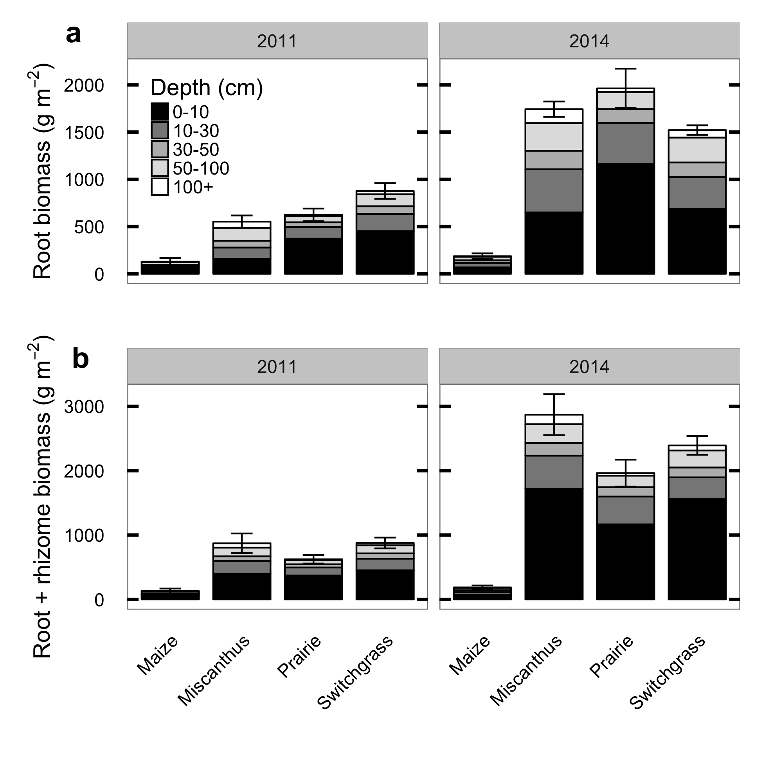

Figure 3.1: Biomass in roots and rhizomes of biofuel crops, as measured by coring in 2011 and again in 2014, divided by depth horizon. Error bars show mean ± 1 standard error of total profile biomass in each block. The 2011 data are re-plotted from (Anderson-Teixeira et al. 2013).

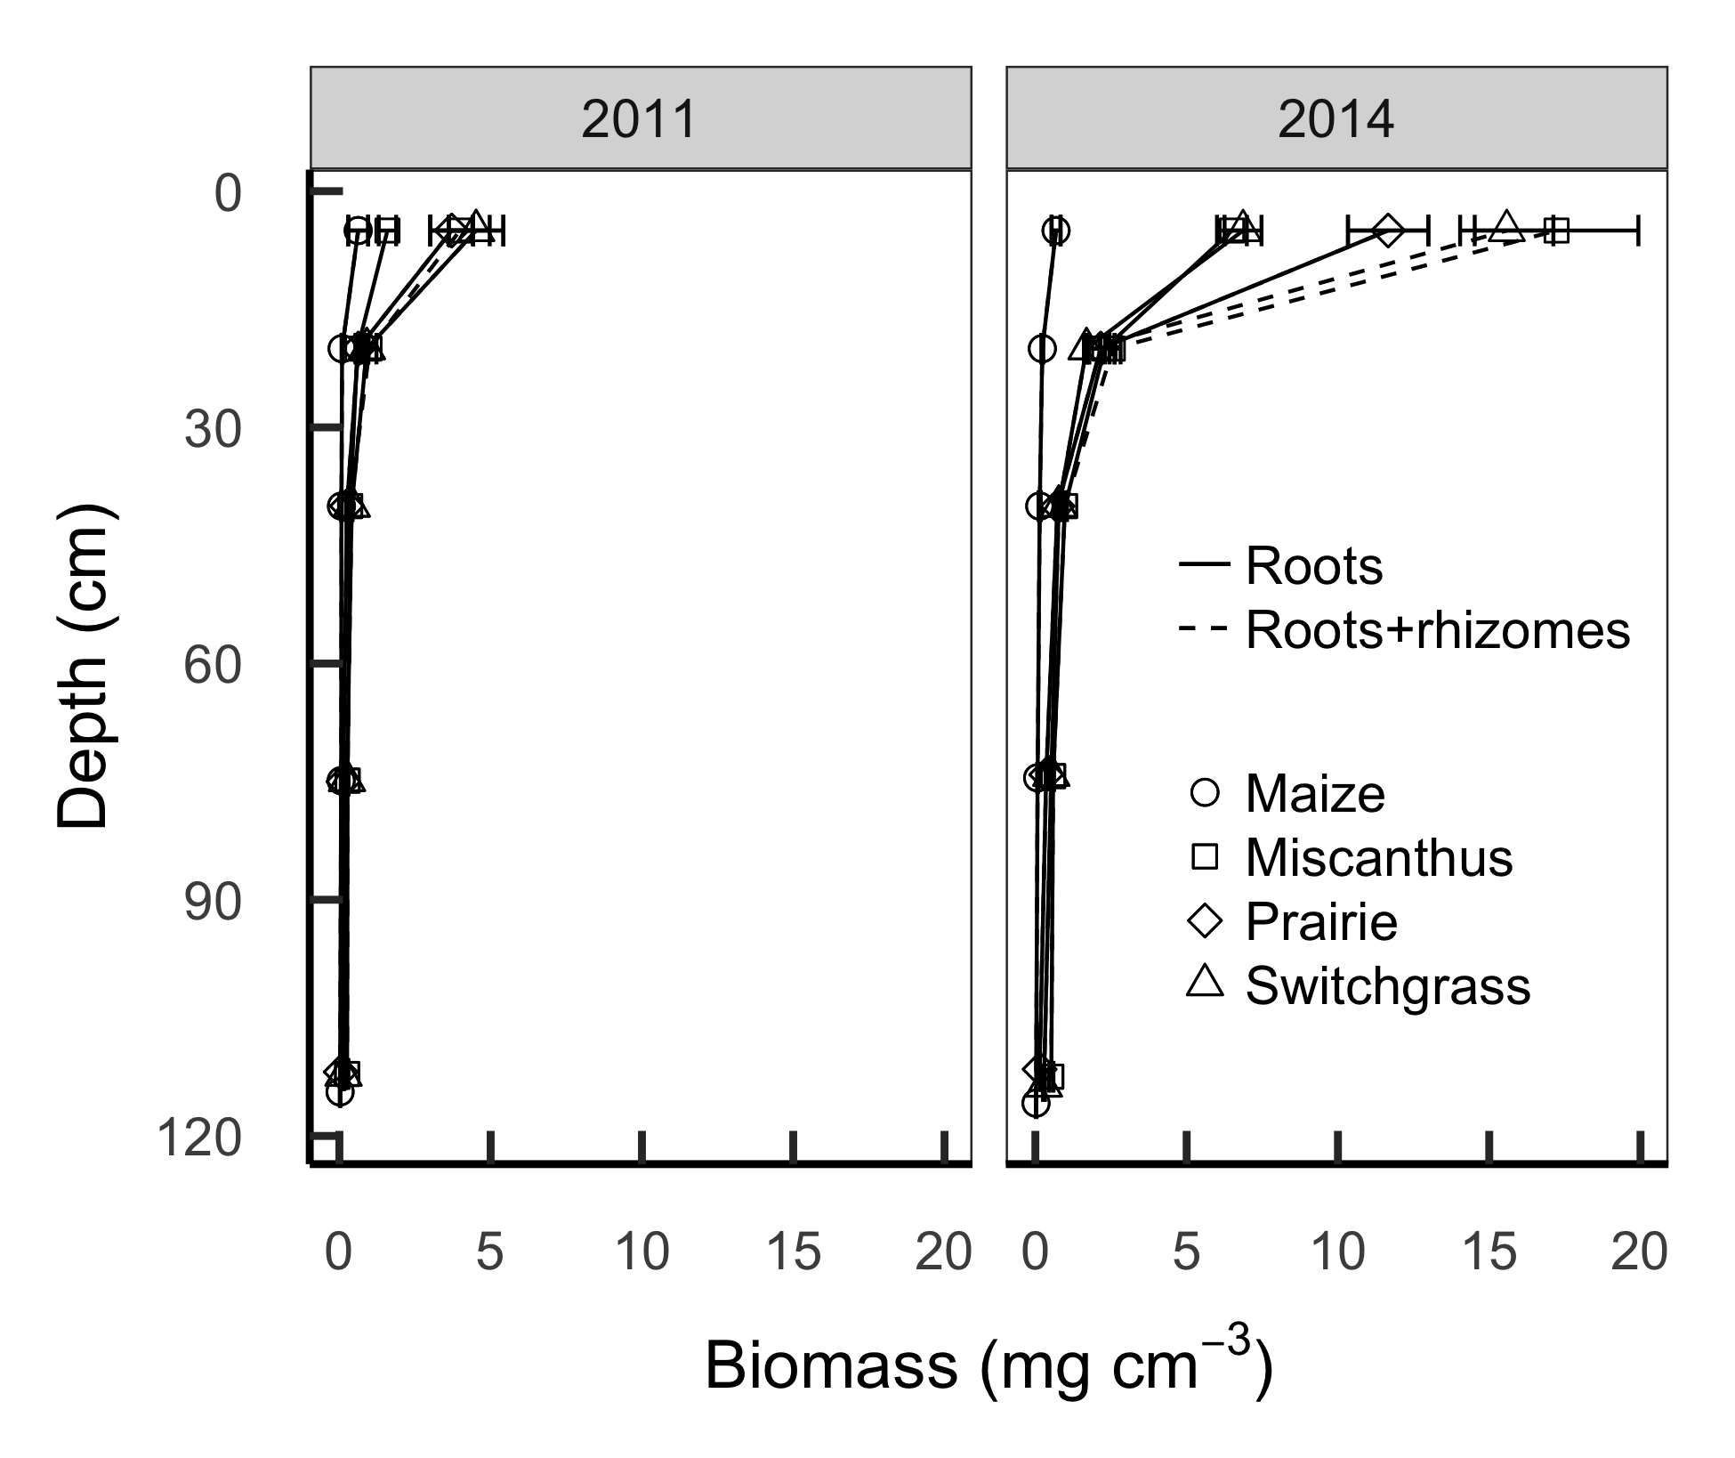

Figure 3.2: Depth profiles of root and root+rhizome mass measured by deep coring in 2011 (left) and again in 2014 (right). The 2011 data are replotted from (Anderson-Teixeira et al. 2013).

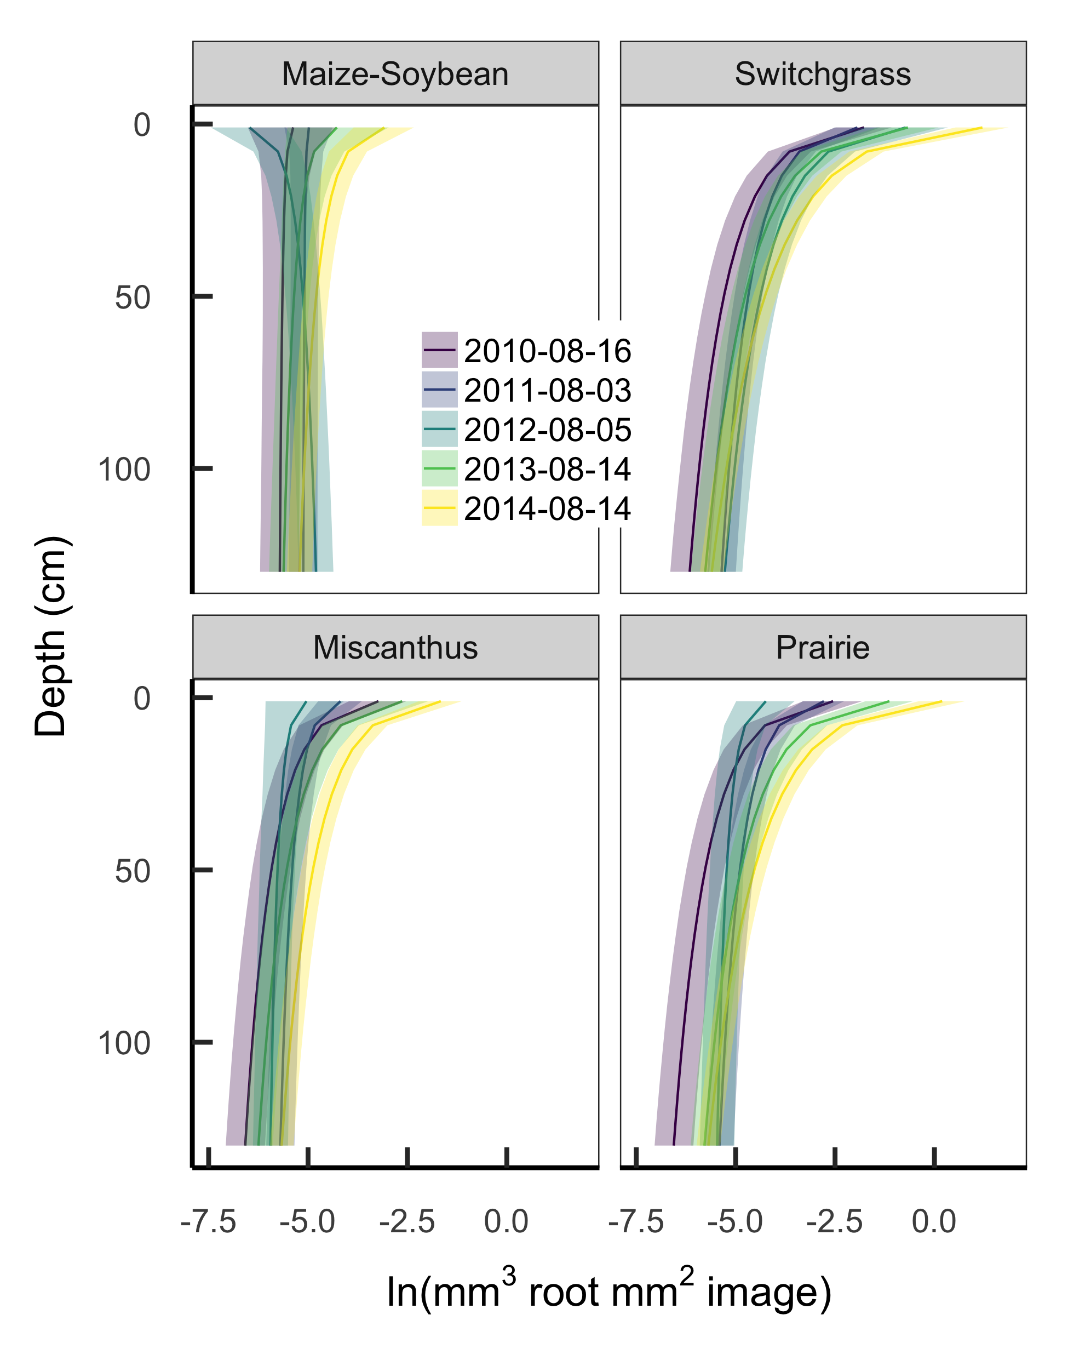

Figure 3.3: Mean ± 50% intervals of estimated root volume density from minirhizotron images collected at peak aboveground biomass each year from 2010-2014.

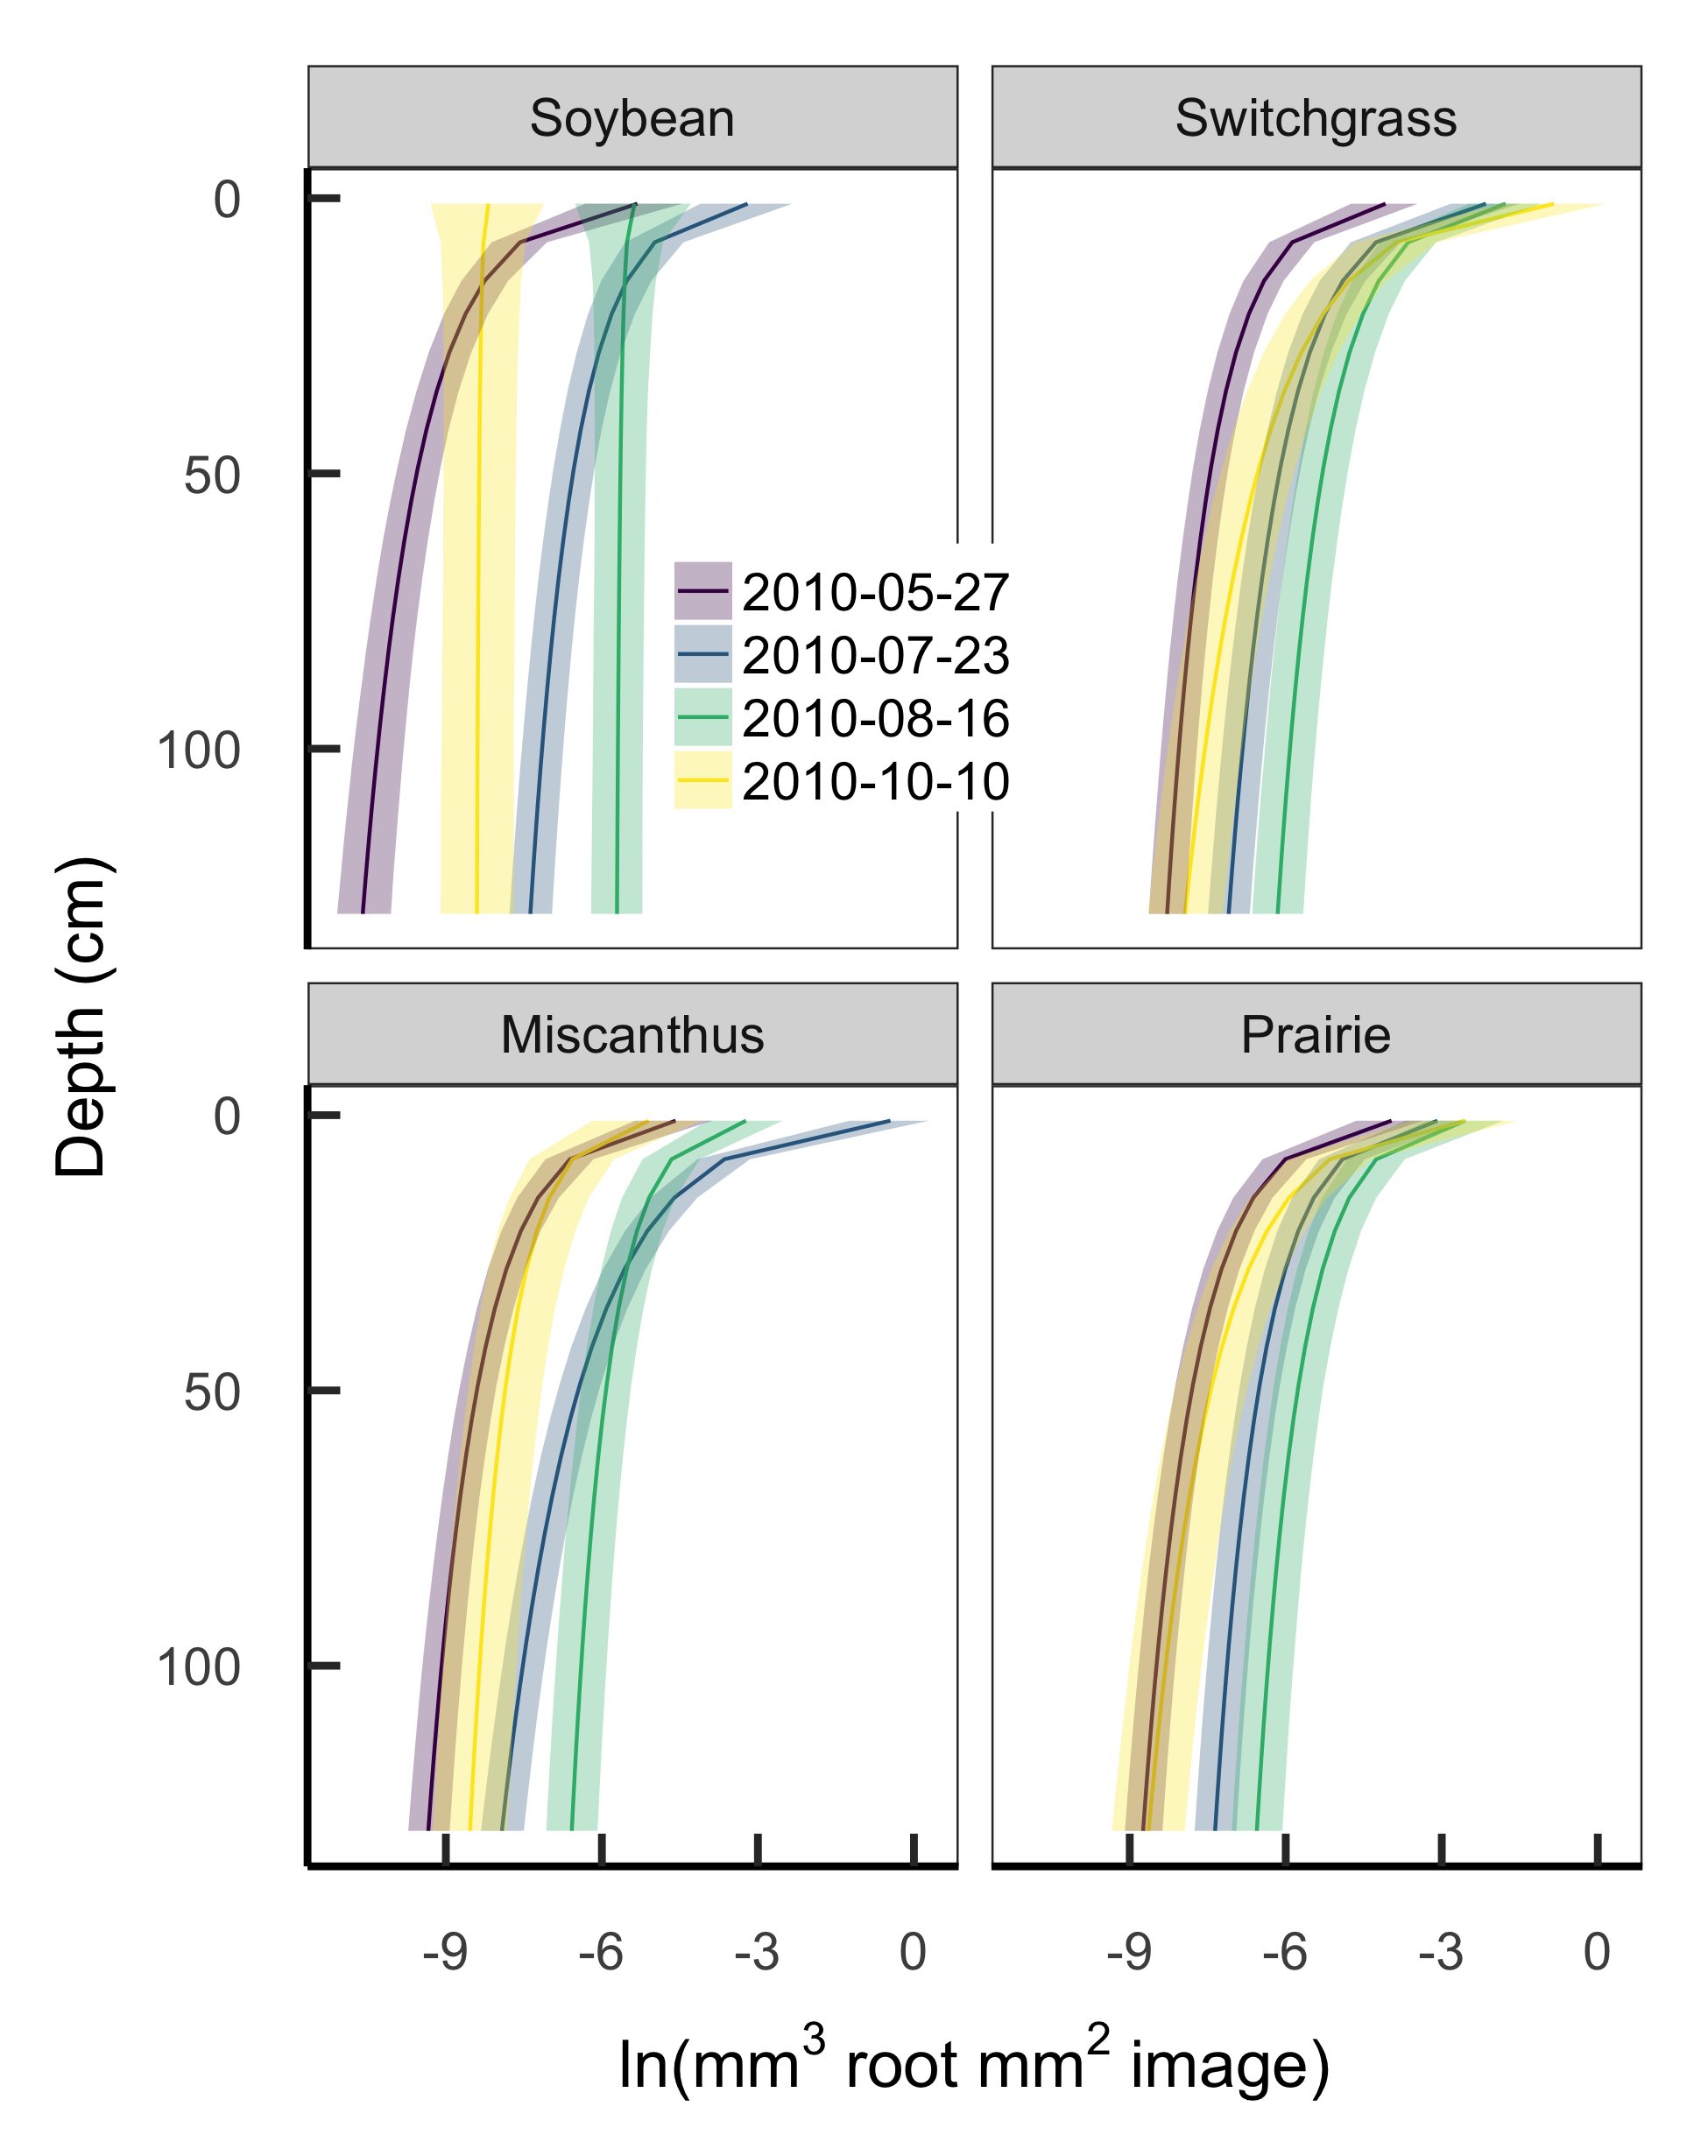

Figure 3.4: Mean ± 50% intervals of estimated root volume density from minirhizotron images collected in summer 2010. Each color shows a different sampling session.

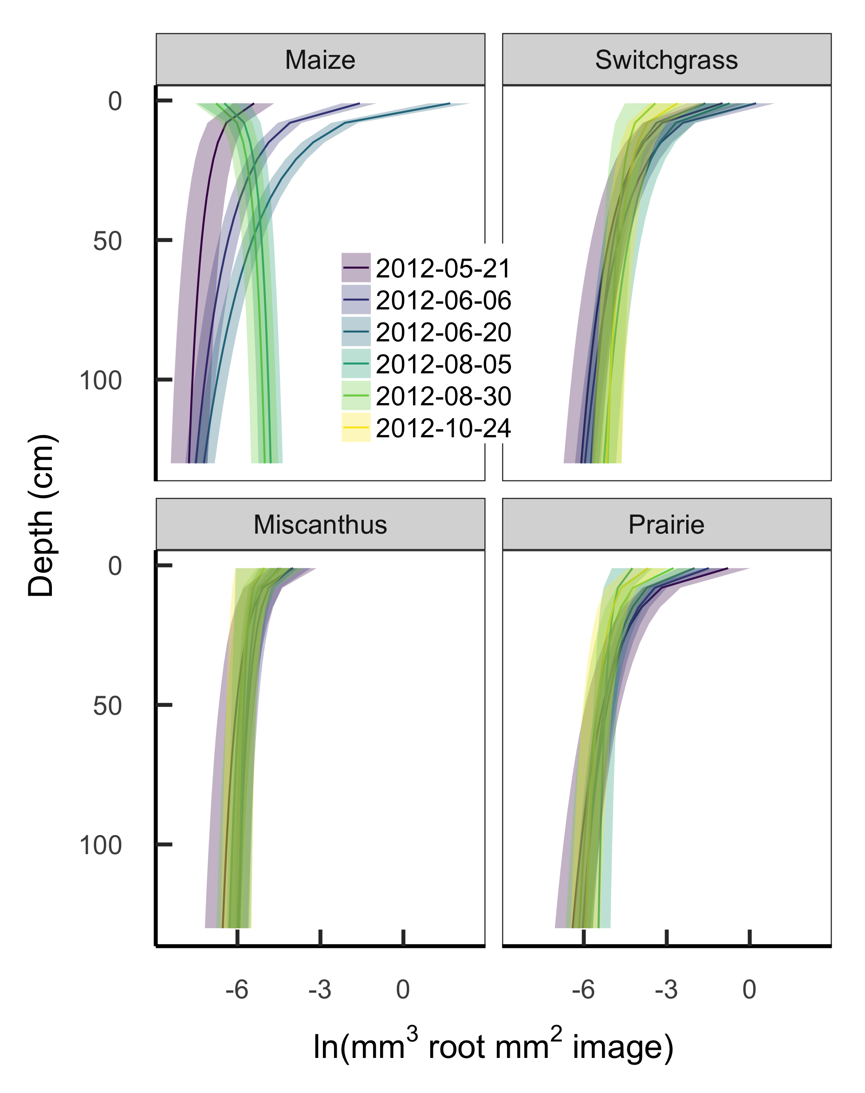

Figure 3.5: Mean ± 50% intervals of estimated root volume density from minirhizotron images collected in summer 2012. Each color shows a different sampling session.

## Supplement 3.1: Selection of priors for model parameters

Our goal for most model parameters was to provide priors that were weakly informative in the sense of Gelman (2006). That is, we aimed to have our posterior estimates mostly informed by the data but with the priors adding sufficient information to avoid unreasonable parameter combinations, thus aiding identifiability and reducing computation difficulty. In particular, our priors for the surface underdetection parameters $α^{surface}$ and $β^{surface}$ use information from other published minirhizotron work but for all other parameters we set our priors with reference to the numeric constraints on visible root volume per image rather than directly from previous biological research.

As a starting point for parameters that need to be specified on the same scale as the data, we derived the expected range of observations by reasoning that root volume cannot exceed 1 mm3 root mm-3 soil and is probably undetectable when roots occupy less than 1 pixel per image, or mm3 at our typical magnification levels of 0.02-0.025 mm2 px-1. Therefore, when modeling on the log scale we expect observed root volumes to fall within a range narrower than $[ln(6×{10}^{-6}),ln(1)]$, or roughly -12 to 0. This leads to the following priors:

* The model intercept term $α_{i}$ is the expected log volume at mean depth for a given species, and should be able to take any value in the range of observable root volumes. We set it separately to $N(-6,6)$ for each crop.
* The slope term $β_{i}$ is the change in expected log volume per log cm of depth. Prior minirhizotron work has usually found that root volume decreases with depth but is still detectable (i.e. ln(root volume) > -12) at depths greater than 1 m. Since ln(root volume at surface) $≤$ 0, this implies a change of less than $-12/ln(100)≈-2.6$, but we allow the possibility of steeper slopes (e.g. annuals that have not yet achieved full rooting depth) and set the prior separately to $N(-1,5)$ for each crop.
* Residual variance $ϵ_{i}$ cannot be less than zero or greater than the variance of the whole dataset. Taking (-12, 0) again as the maximum possible observed range of the full dataset and approximating the range of a Normal distribution as four sigmas, $0≤ϵ_{i}≤12/4=3$, so we set the prior to a folded Normal(0, 3).
* Variation among individual minirhizotron tubes $σ^{tube}$ has the same possible range as $ϵ$, so we use the same prior: folded $N(0,3)$.
* The location $α^{detect}$ and scale $β^{detect}$ of the root detection probability $ϕ=p(detect|\overset{^}{μ},α^{detect},β^{detect})$ can vary between two conceptual extremes: If zeroes arise mostly from low root volume, then $ϕ$ will have a sharp threshold at some low $\overset{^}{μ}$ corresponding to the boundary of effective image resolution. Conversely, if zeroes arise mostly from heterogeneity around a relatively high volume, then $ϕ$ will rise slowly and $α^{detect}$ will be large. Interpolating between these extremes, we reason that the effective image resolution must be coarser than 1 pixel and that even with pure heterogeneity and infinitely small samples we would still expect to detect roots more than 50% of the time if roots fill more than 50% of the soil volume, so $-12≤α^{detect}≤ln(0.5)=-0.69$. Since this reasoning is extremely vague, we add that our detection is probably better than chance (our samples are not infinitely small) and set our prior to be quite weak but with its peak below the center of the possible range: $N(-8,10)$.
* Reasoning similarly for $β^{detect}$ as for $α^{detect}$, if $ϕ$ is “low” (say, less than 0.05, or approximately -3 on the standard logistic scale) at $\overset{^}{μ}<=-12$ and at least 0.5 (=0 on the standard logistic scale) at $\overset{^}{μ}>=-0.69$, this corresponds to a change of at least 3 units on the standard logistic scale in the space of 11 log units, or $β^{detect}≤11/3≈3.66$, or possibly much less if $ϕ$ is a steep threshold. This too is vaguely reasoned, so we set the prior weak enough to allow values somewhat outside this range if they are consistent with the data: folded $N(0,6)$.

For the surface underdetection function, the expected scale of the root volume data offers little guidance. Instead, we relied on previously published data, especially on a comparison of minirhizotron and core break root counts in a spring oat crop (Bragg et al. 1983, especially their Table 1). Assuming that these observations apply to other grasses and that the underdetection for root counts is comparable to that for root volume, the key finding from this and other papers (Samson and Sinclair 1994, Ephrath et al. 1999) is that only about 10-20% of roots were detected in the surface soil, rising to “full detection” (>95%) at depths greater than about 30 cm. Converting these percentages to the log-odds scale, this is a change of $(|-ln(1/0.1-1)|=2.19)+(-ln(1/0.95-1)=2.94)≈5$ units on the standard logistic scale, implying that the half-detection depth $α^{surface}$ is around 13 cm and the scale $β^{surface}$ is about 6. This is qualitatively comparable with other papers that report underdetection near the surface by minirhizotron methods, but few others have reported the comparison in enough detail to plot the curve. We set our prior for $α^{surface}$ as $N(13,10)$ and $β^{surface}$ as $N(6,5)$.

## Supplement 3.2: Supplemental figures

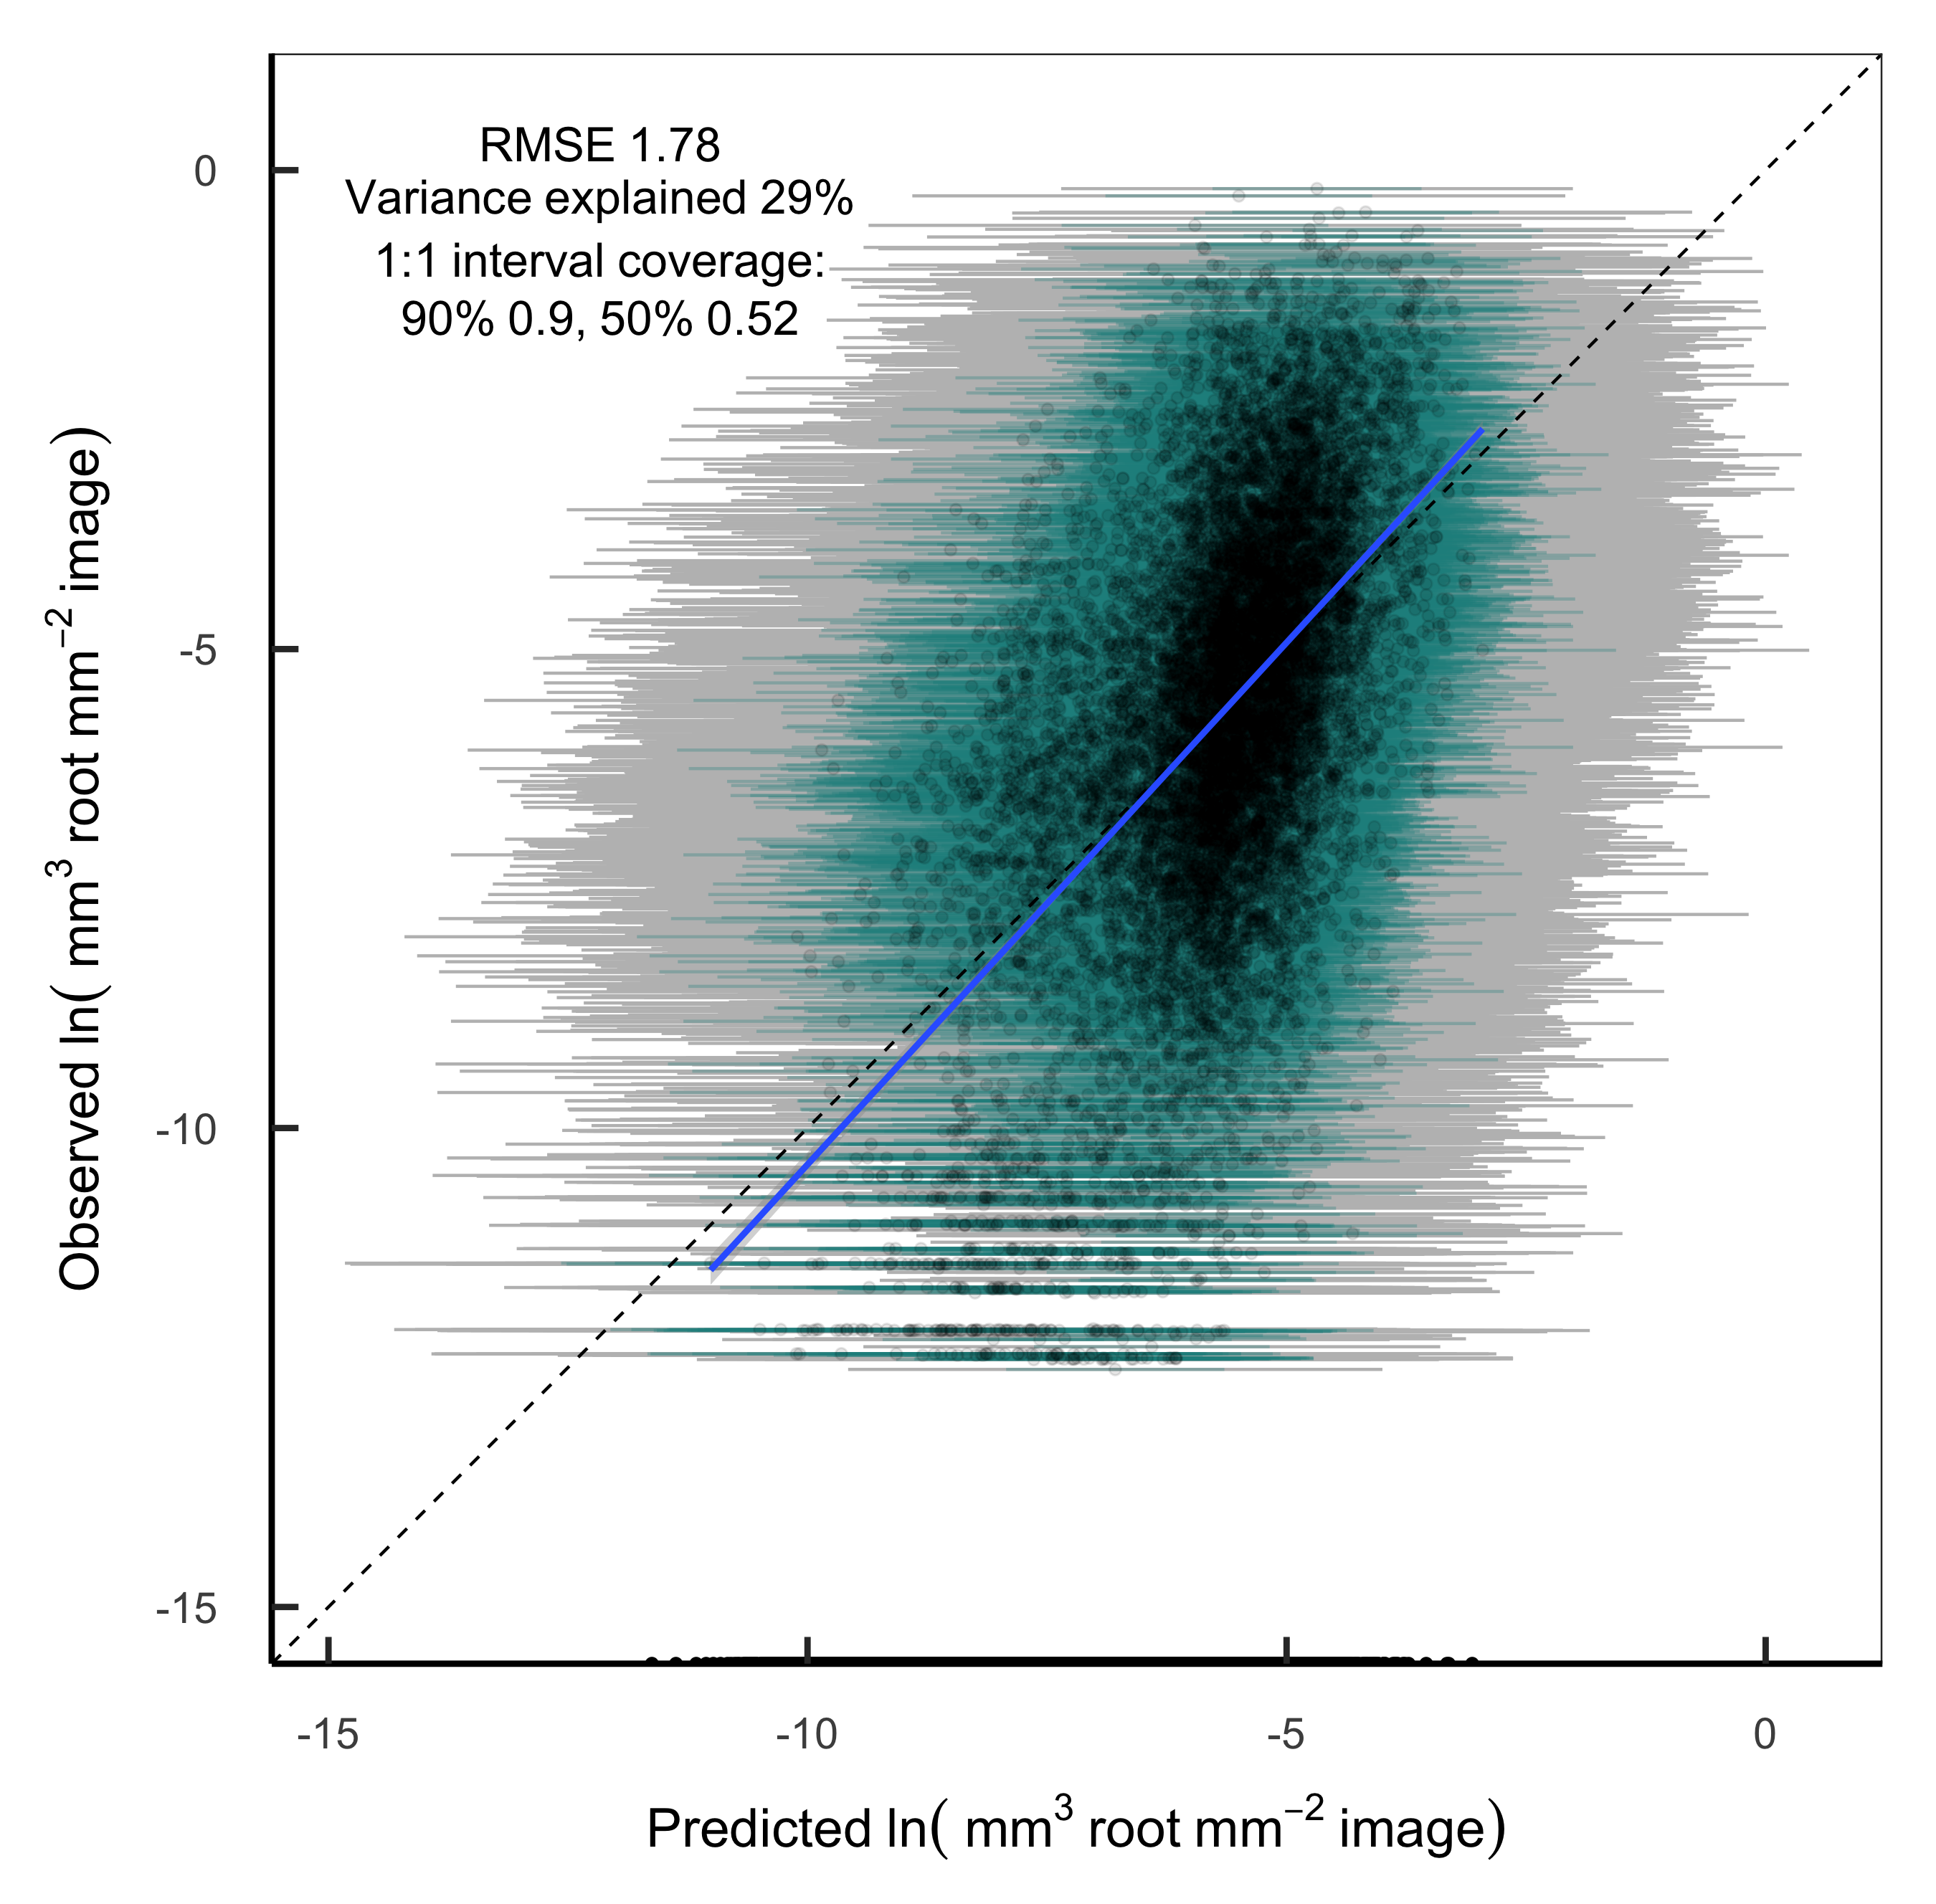

Figure 3.S1: Observations versus predictions of visible root volume in individual minirhizotron images. Bars show prediction intervals (grey: 90%; blue: 50%), for newly observed images at the same location. The points along the bottom of the image indicate model predictions for images with zero observed roots and are not included in the regression.

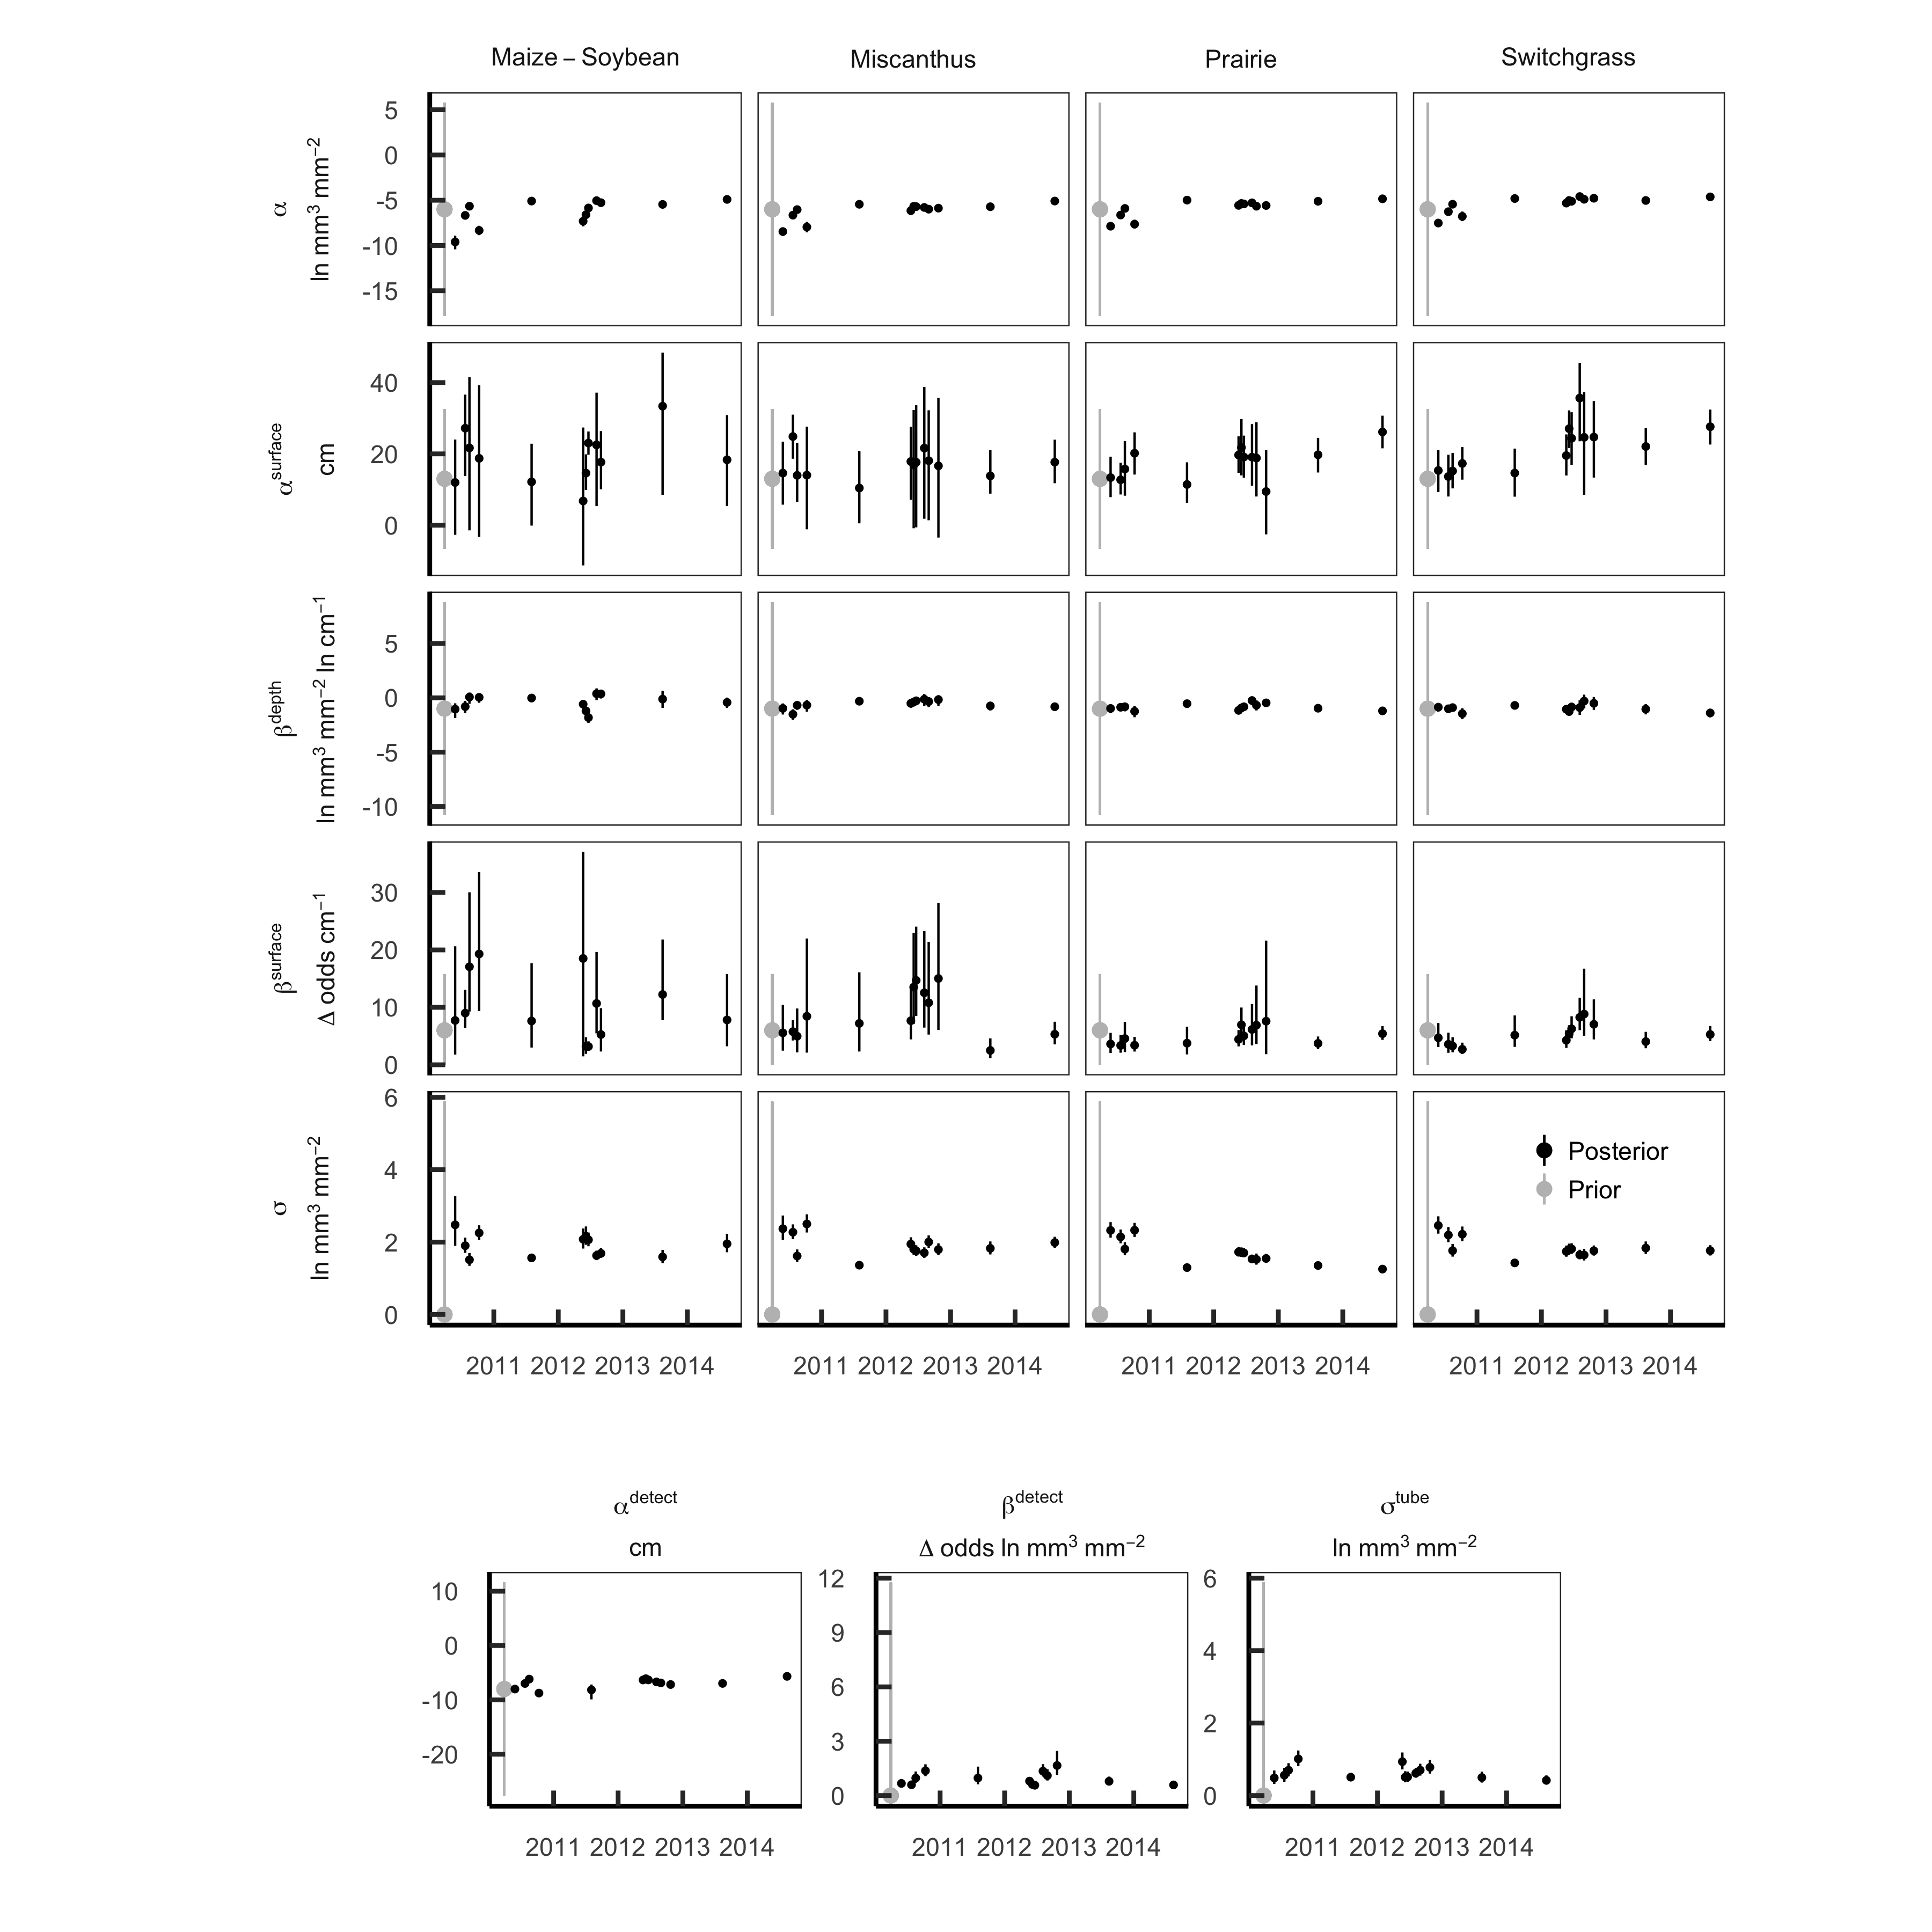

Figure 3.S2: Model parameter estimates. The grey bar at the left edge of each panel shows the mean ± 95% credible interval of the prior distribution; black bars show posterior mean ± 95% credible interval for each sample day.

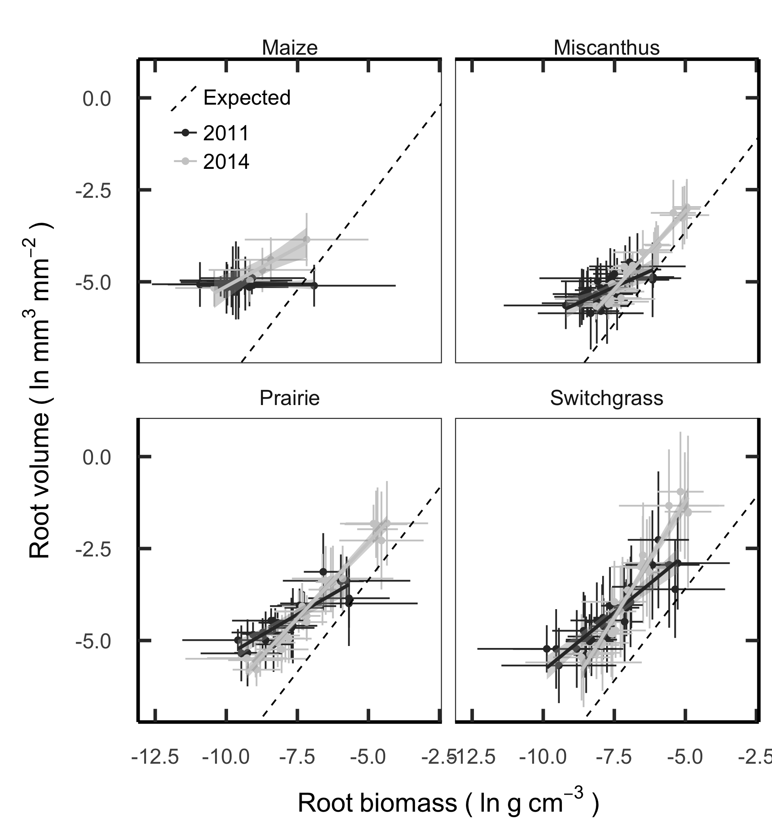

Figure 3.S3: Comparison between root mass measured from soil cores and estimated from minirhizotron images taken in midsummer 2011 and 2014. Each point shows the mean ± 95% interval for one depth layer (0-10, 10-30, 30-50, 50-100 cm) in one experimental plot. Dashed lines show the expected relationship between root mass and volume assuming a 0.78 mm depth of view and constant root tissue densities of 0.08 (maize), 0.20 (*Miscanthus*), 0.19 (switchgrass), or 0.15 (prairie) g cm-3.